(BE-2016) CSE

**BUSINESS INTELLIGENCE AND DATA WAREHOUSING LAB**

**(CSP1310)**

**COMPUTER SCIENCE AND ENGINEERING**

**B.E. Batch-2016**



|  |  |
| --- | --- |
| **Submitted To :** | **Submitted By:** |
|  |  |
|  |  |
|  |  |
|  |  |
|  |  |
|  |  |
|  |  |
|  |  |
|  |  |
|  |  |

**SCHOOL OF COMPUTER SCIENCES**

**CHITKARA UNIVERSITY**

**PUNJAB**

**PRACTICAL NO: 1**

**AIM: Introduction to Pentaho**

What is PENTAHO?

Pentaho provides an open, unified platform to access, integrate and blend any data, in any environment, across a full spectrum of analytics. Pentaho was founded in 2004 by 5 founders and was acquired by HITACHI DATA SYSTEM in 2015.

Pentaho is also known as KETTLE.

VERSIONS AVAILABLE:

1. Pentaho Enterprise Edition (EE)
2. Pentaho Community Edition (CE).

We are using version 6.1 Pentaho Community Edition (CE)

Advantages of Pentaho:

1. **Open Source Licensing**

1. Software code is free
2. Dramatically lower up-front and ongoing costs

2. **Superior relationship**

1. Complete transparency
2. Relationship based 100% on quality of customer support
3. No “vendor lock in” simply based on access to future upgrades

3.**Reduced risk**

1. Delivering “whole product” using an open source core – support, training, documentation, global partner network, consulting, product management, quality assurance, longevity

4. **Enterprise Development Methodology**

1. Innovative, enterprise-quality products via a professional methodology
2. Superior development productivity and commercial quality via extensive QA
3. Continuous testing in diverse environments by a huge global community ,transparent, detailed road-map, product road-map, core development, and project contributions managed by Pentaho

5. **Componentized and modular for flexibility and easy customization**

STEPS TO INSTALL PENTAHO:

1. Double Click on SpoonDebug.
2. Enter Y
3. Enter Y
4. Enter Y
5. Pentaho will take a while and start In your PC.

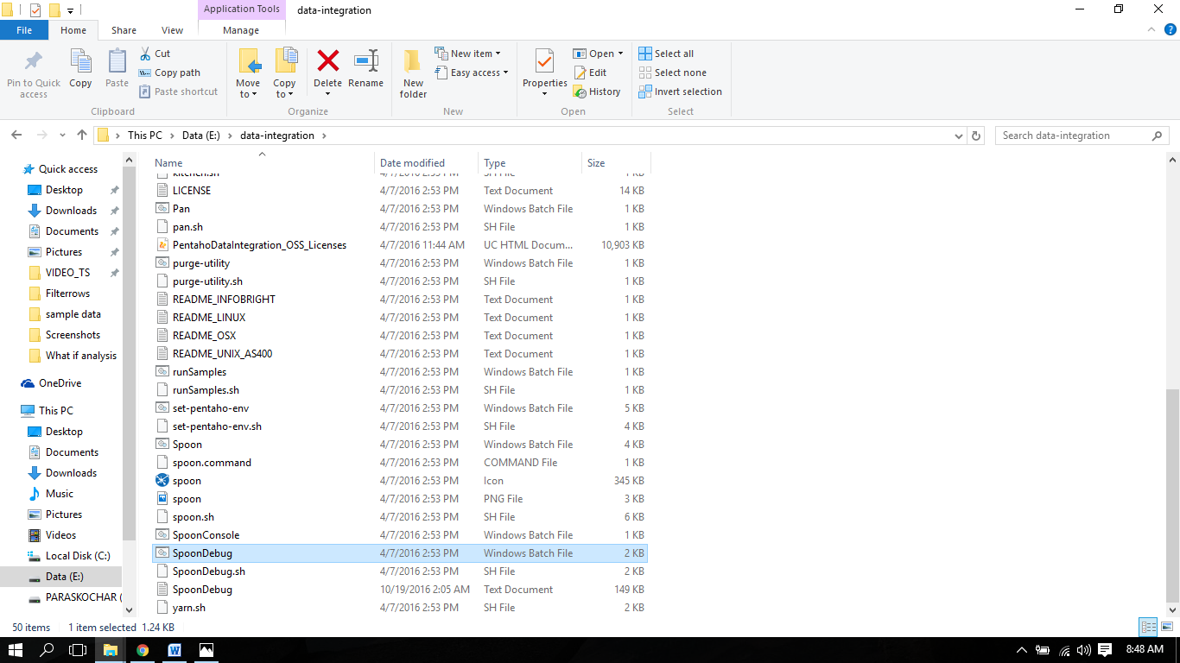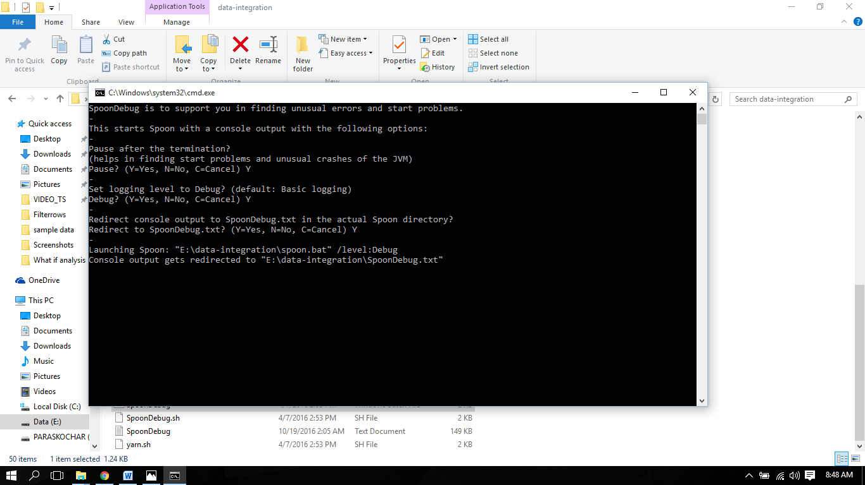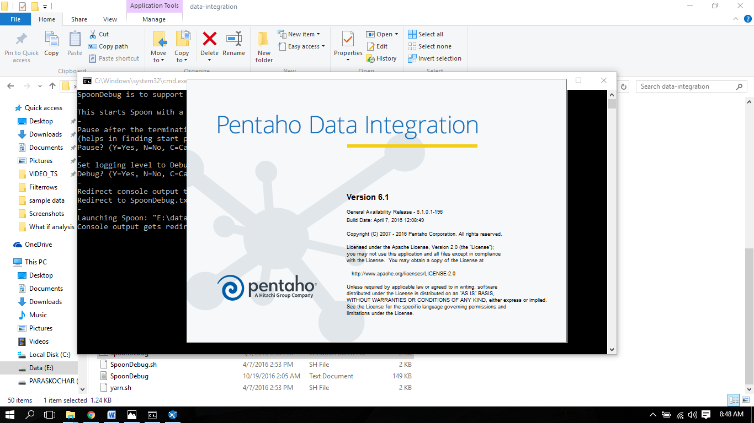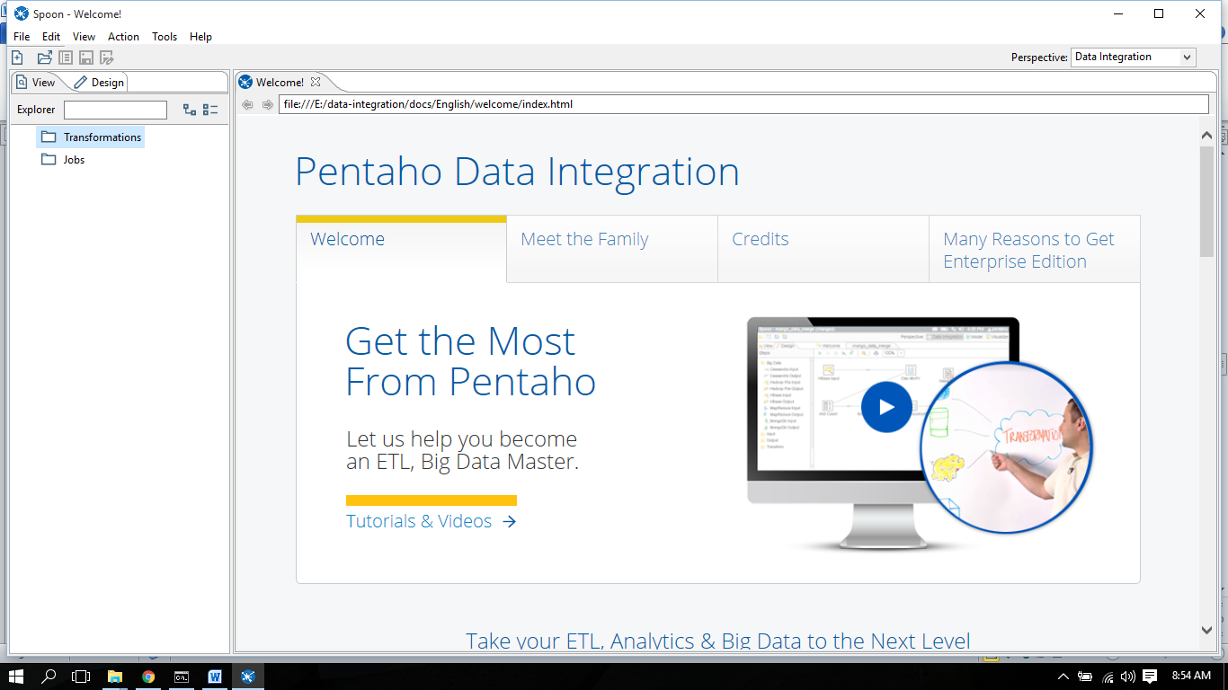

**PRACTICAL NO: 3**

**AIM: Pivot Table chart**

Pivot Tables allow you to consolidate huge amounts of data with similar fields & analyze the consolidated data or just make a summary of the consolidated data. The Pivot Table in Excel gives you a simple way to create a Pivot Table for your data. Please note that the data should have atleast1fieldin common else, the consolidation will not work and any spelling error in the data will produce incorrect Pivot Tables.

**Scenario1: Graph the percentage sales over time to seethe trends.**

|  |  |  |  |  |  |  |  |  |  |
| --- | --- | --- | --- | --- | --- | --- | --- | --- | --- |
| **Sum of Quantity**  **Row Labels** | **Column Labels**  **Beverages** | **Condiments** | **Confections** | **Dairy Products** | **Grains/Cereals** | **Meat/Poultry** | **Produce** | **Seafood** | **Grand Total** |
| Calendar1996 | 20.85% | 11.69% | 15.00% | 18.78% | 6.30% | 8.88% | 5.02% | 13.49% | 100.00% |
| Calendar1997 | 15.80% | 11.02% | 15.90% | 18.23% | 10.18% | 8.68% | 5.76% | 14.43% | 100.00% |
| Calendar1998 | 21.15% | 9.05% | 14.96% | 17.17% | 7.76% | 7.45% | 5.76% | 16.70% | 100.00% |
| **Grand Total** | **18.38%** | **10.45%** | **15.45%** | **17.95%** | **8.78%** | **8.29%** | **5.65%** | **15.07%** | **100.00%** |

**Category-wise Sales Trends over the years**

Beverages Condiments Confections Dairy Products Grains/Cereals Meat/Poultry Produce Seafood

Calendar1998

21.15%

9.05%

14.96%

17.17%

7.76%

7.45% 5.76%

16.70%

Calendar1997

15.80%

11.02%

15.90%

18.23%

10.18%

8.68%

5.76%

14.43%

Calendar1996

20.85%

11.69%

15.00%

18.78%

6.30%

8.88%

5.02%

13.49%

Now how do you get to this?

**Creating a Pivot Table and Pivot Chart**

1. Open the **Northwind_Tradersdata.xlsx** workbook.

2. Go to the **Insert** tab on the ribbon.

3. Look for the **Tables** group,and select **Pivot Table**. Choose **Pivot Chart** from the drop-down options.

4. You should now see the *Create Pivot Table with Pivot Chart dialog box.*

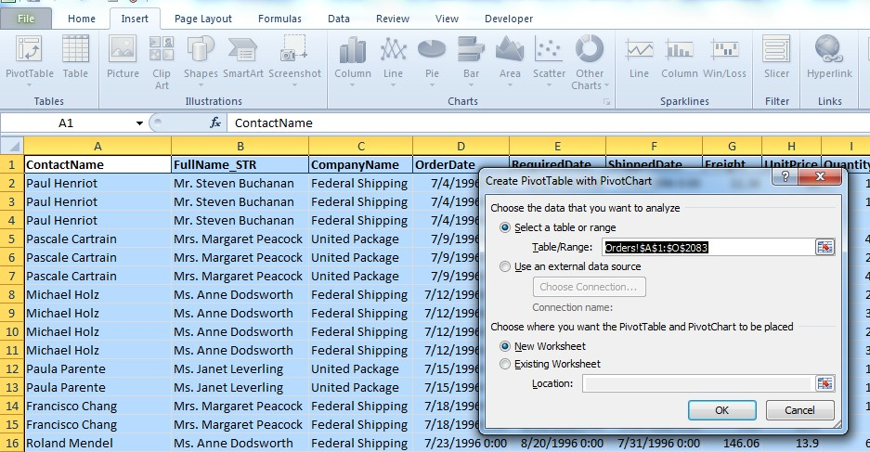

5. There area couple of things you’ll need to define in order to create your Pivot Table. First, you need to tell Excel from where to get the data. In the *Choose the data you want to analyze* section of the dialog box, you will define where Excel is going to get the data for the Pivot Table. Since the data for this example is within the workbook, we will choose **Select a table or range**. Under

a. **Table/Range**, Excel might be smart enough to automatically select the proper range of data from the worksheet. If it does not, click on the little button on the right of the range box.

b. Select the range of data. In the example, we have data in cells **A1toO2083**. This means that we have selected six columns (A through O) and 2083 rows.

6. In the *Choose where you want the Pivot Table and Pivot Chart to be placed* section of the dialog box, you can choose to either create the Pivot Table and accompanying Pivot Chart on a new worksheet in the Excel workbook, or you can place both on the current worksheet. For this exercise, we will choose to create a new worksheet for the Pivot Table and Pivot Chart. To do this, select **New Worksheet**. Click **OK**. You should now be taken to the new worksheet.

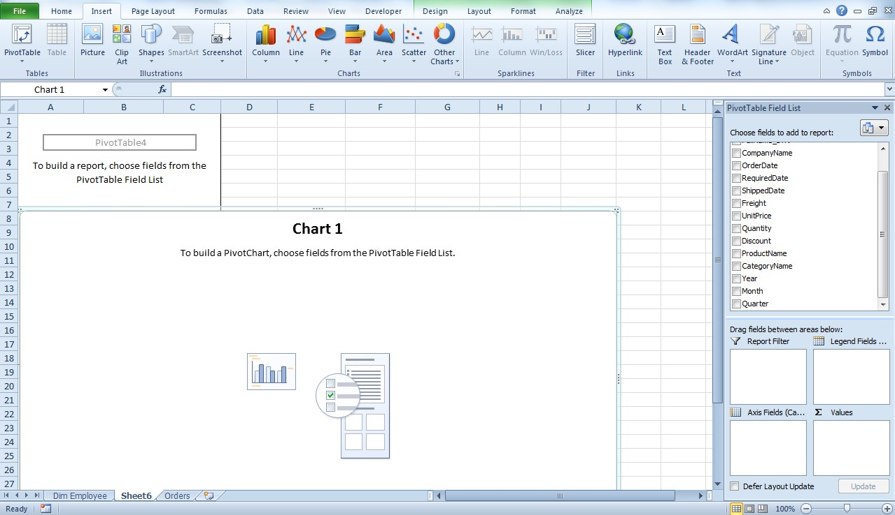

1. While on the new worksheet, you should see four new tabs on the ribbon:

a. **Design**, **Layout**,**Format**, and **Analyze**.

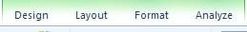

b. You should also see the **Pivot Table Field List** and the **Pivot Chart Filter Pane** (if you don’t see the panes, clicks on the **Analyze** tab in the ribbon, and, in the **Show/Hide** group, make sure that at least **Field List** is selected).

7. You now need to setup the Pivot Table so that you can get the data summary you desire. The new tabs, as well as the two panes, will be used to help format your Pivot Table and Pivot Chart to do the necessary analysis. For this exercise, let’s see the total number of products sold by category in each year. In the **Pivot Table Field List**, select Quantity, Year and **Category Name** to add to the Pivot Table report. Place the Category Name in the Legends field, Year in Axis Fields and Quantity in Values fields. You should see the Pivot Table and Pivot Chart update appropriately. Select the chart type as ‘Stacked List’ to get the chart as shown below

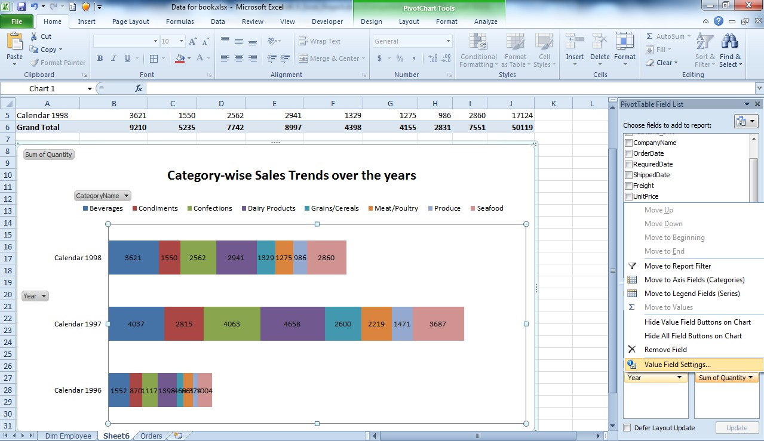

You can use different functions on the field placed under *Values*. For example, if you wanted to see average quantity for each category, you would click on **Sum of Quantity** and choose **Value Field Settings**. In the **Value Field Settings** dialog box, choose the ‘Show Values As ’tab and select ‘% of Row Total’ function to apply to **Sum of Quantity** (see the screen-shot below). A number of other functions are available here to use in your Pivot Table.

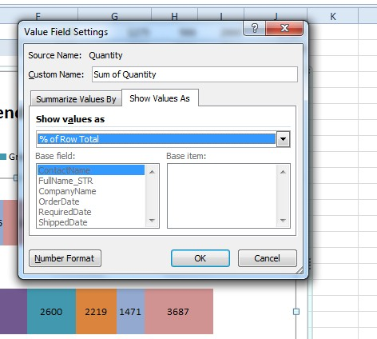

**Scenario2: Pivot the data to see total sales by quarter and category. Are there any highs? Are there any lows that need to be addressed?**

(The data has been pivoted in terms of Year and Quarter in columns and Category in Rows)

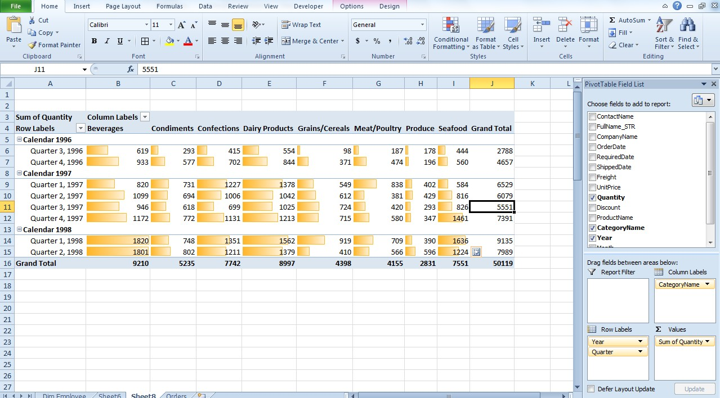

Here is how we do it:

1. Select the entire table in Orders worksheet

2. Go to Insert menu select Pivot Table tab and select Pivot Table

3. Select the columns as highlighted in the circle below (make sure Quantity is represented as sum of Quantity. Else use the previously used Value Field Settings option to sum it)

4. Select the data as shown in the screen-shot below

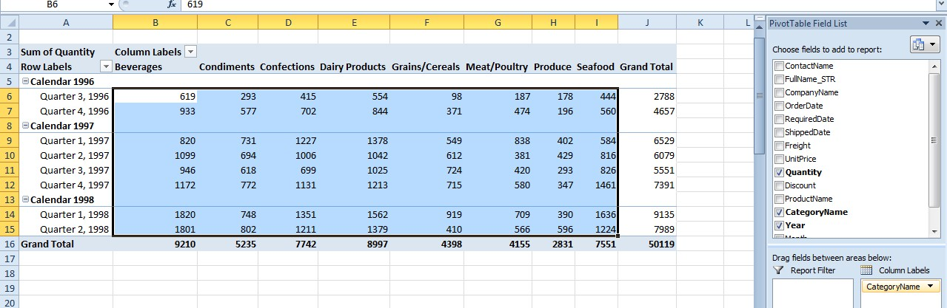

5. Apply the conditional formatting as shown below

(Make sure you are in the Home menu to view the Conditional Formatting tab)

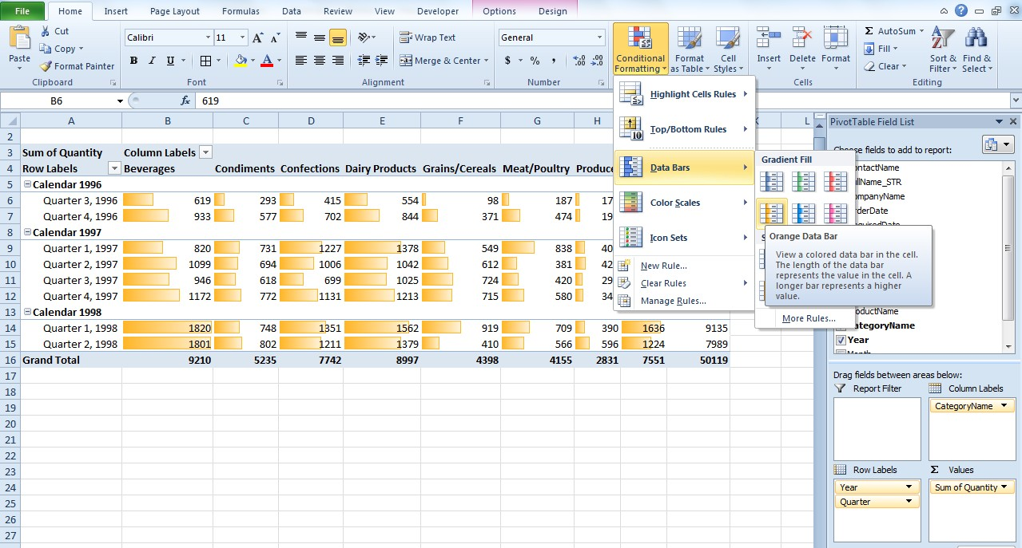

By applying conditional formatting you are able to achieve better visualization of Data. You can observe that 2nd quarter of 1998 had the highest total sales and also the Beverages category had the highest total sales for all years combined closely followed by Dairy products.

**Scenario3: How are quarterly sales totals by sales person? Subtotal the data.**

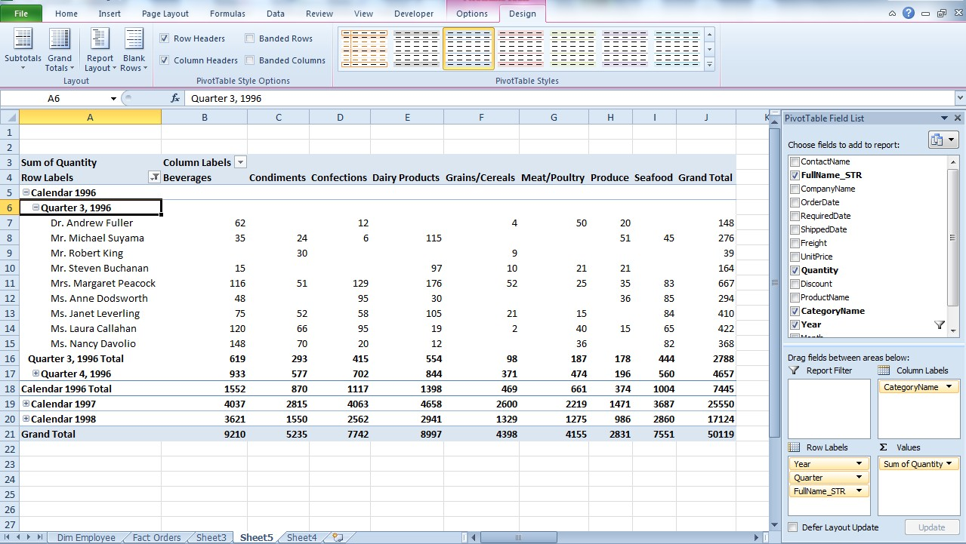

Here is how it is done:

Just drag and drop FullName_STR(Name of the sales person) to the Row Label. Then, in the Pivot Table tools select the Design menu, in the Design menu select the Subtotals tab and then select the option-‘Show all Subtotals’ at Bottom of group as shown below

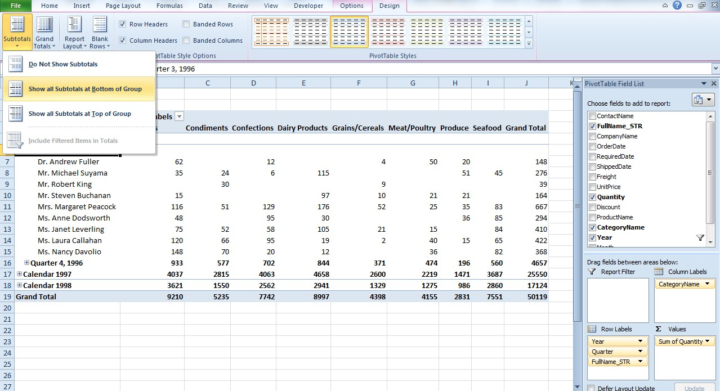

**Customizing a Pivot Chart**

1. Go to the worksheet containing the Pivot Chart, and select the Pivot Chart. You should be able to see the **Design**, **Layout**, **Format**, and **Analyze** tabs on the ribbon.

2. Click on the **Design** tab, and select **Change Chart Type** from the *Type* group. Select the **3-D Column** chart.

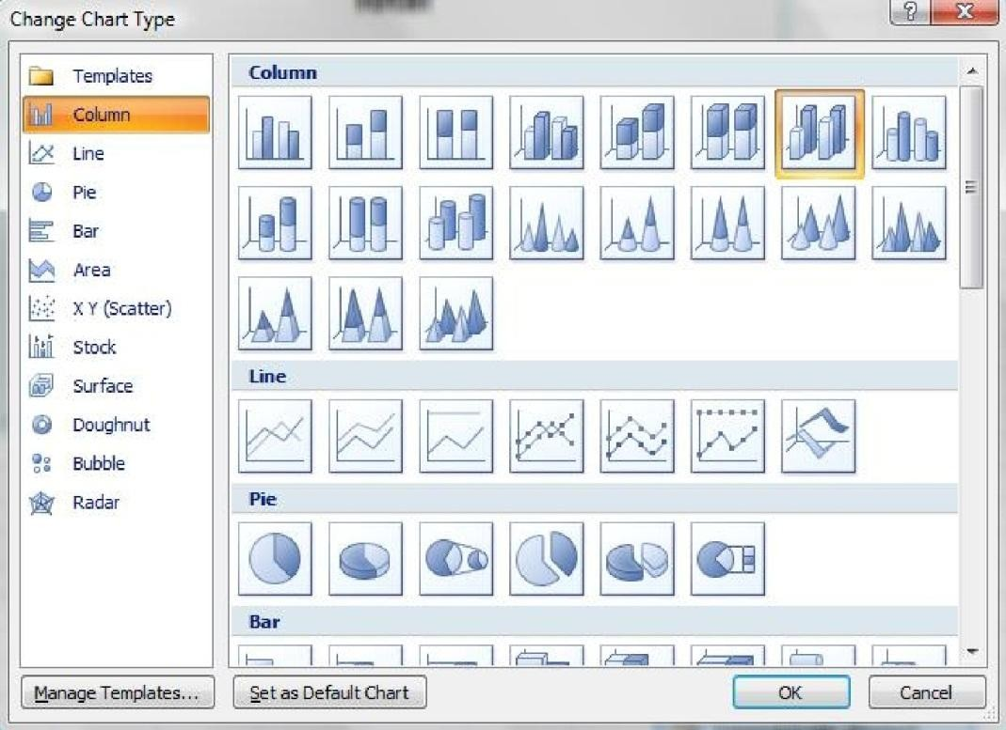

3. We should see the Pivot Chart automatically update using the new chart type.

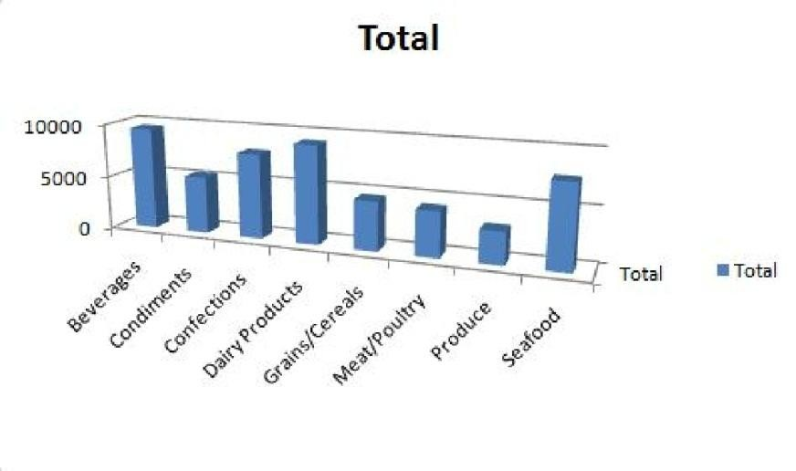

4. Update the title on the chart by clicking on the chart title, and there placing the current title of **Total with North-wind Orders**.

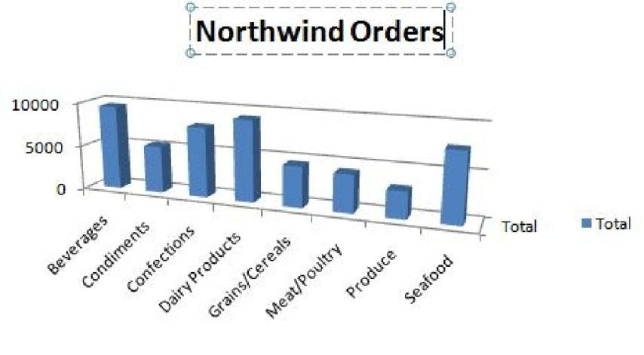

5. We can show the numeric values that each column represents above the respective column by showing the data labels. To do this, go to the **Layout** tab on the ribbon, select **Data Labels** from the *Labels* group, and then choose **Show**.

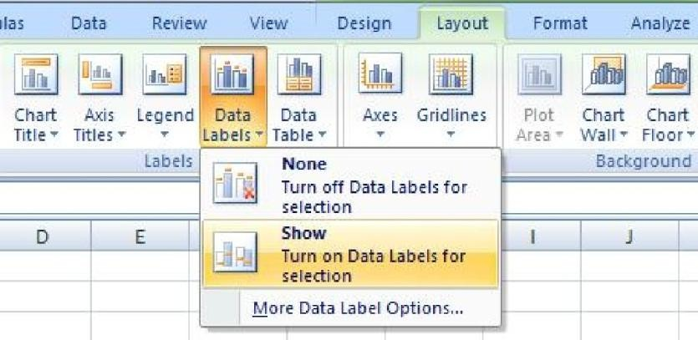

6. Finally, change the color of the columns of the chart. To do this, first click on one of the columns within the Pivot Chart. Then, go to the **Format** tab on the ribbon, select **Shape Fill** from the *Shape Styles* group, and choose the desired color. For the purpose of this exercise, let’s choose **Red**.

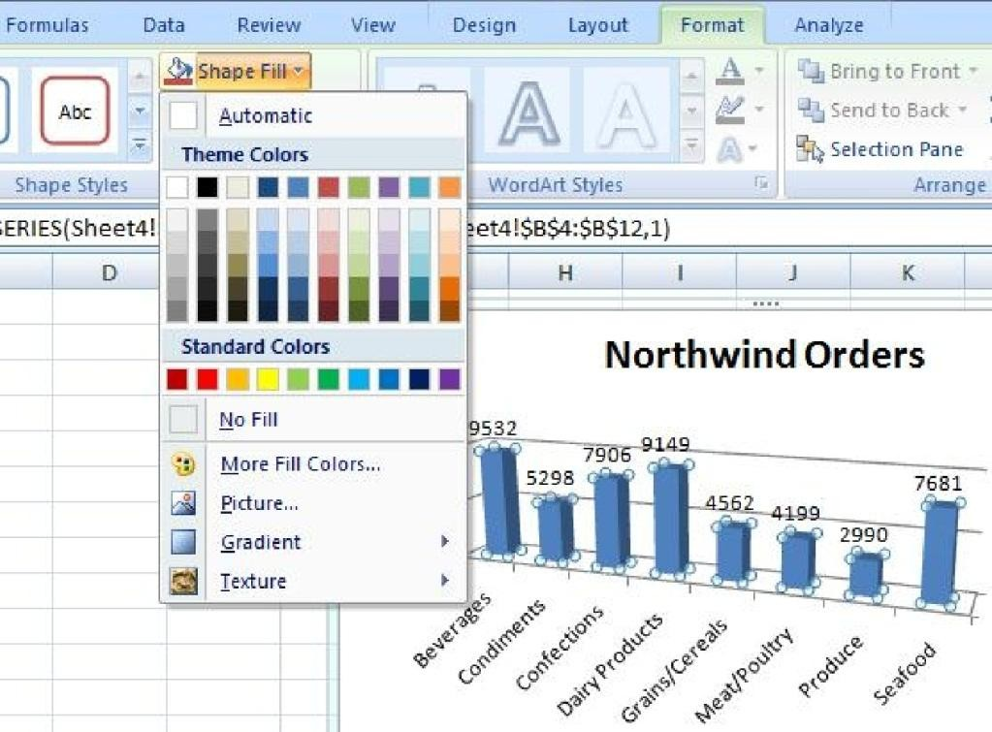

7. Our Pivot Chart should now look similar to the one below.

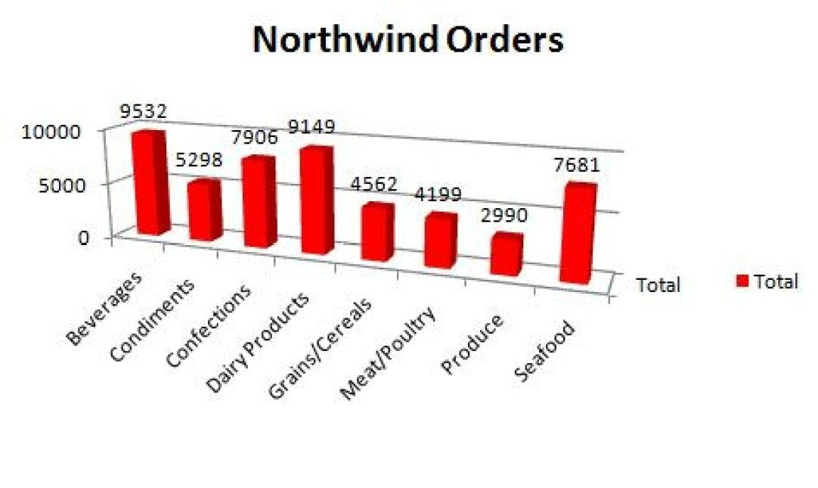

**PRACTICAL NO: 4**

**AIM: What If Analysis**

What if analysis is done with respect to different values and conditions for ex. If we have total 100 lectures for students and criteria of their attendance is 60% then what would be the number of lectures each student should attend. This whole scenario and values are obtained by applying formula and what if analysis.

STEPS FOR WHAT IF ANALYSIS:

1.First of all take a scenario

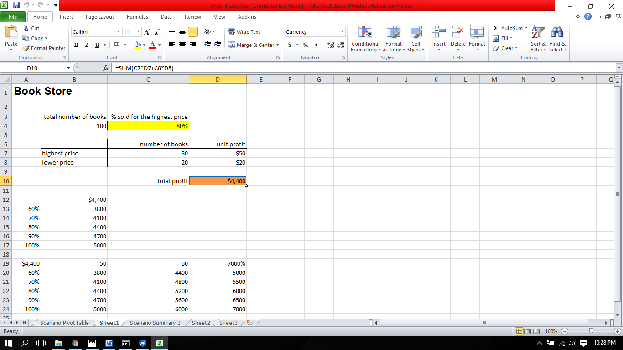

2.Click on what if analysis > Scenario Manager

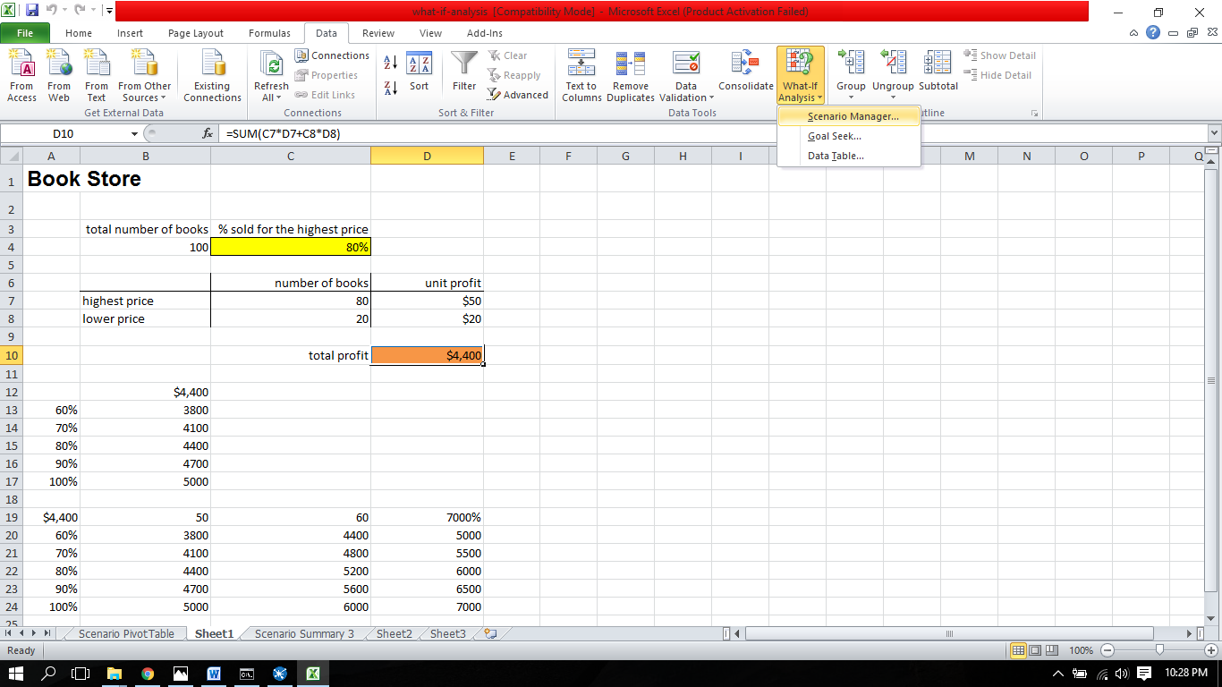

3.Click Add

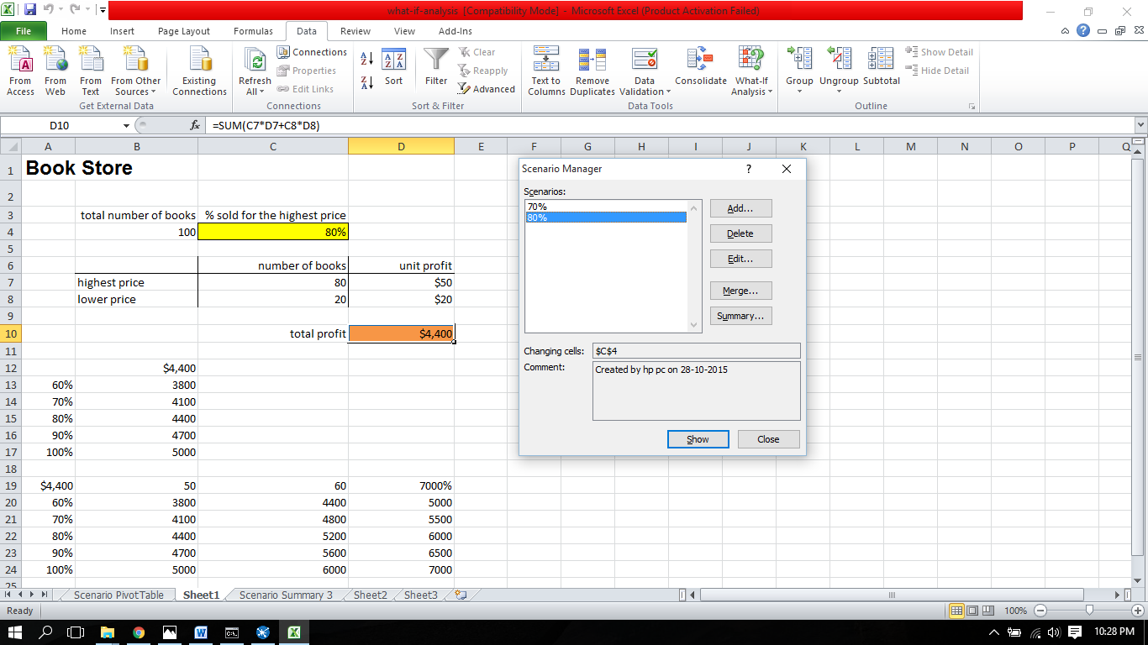

4.Enter Scenario name and changing cell

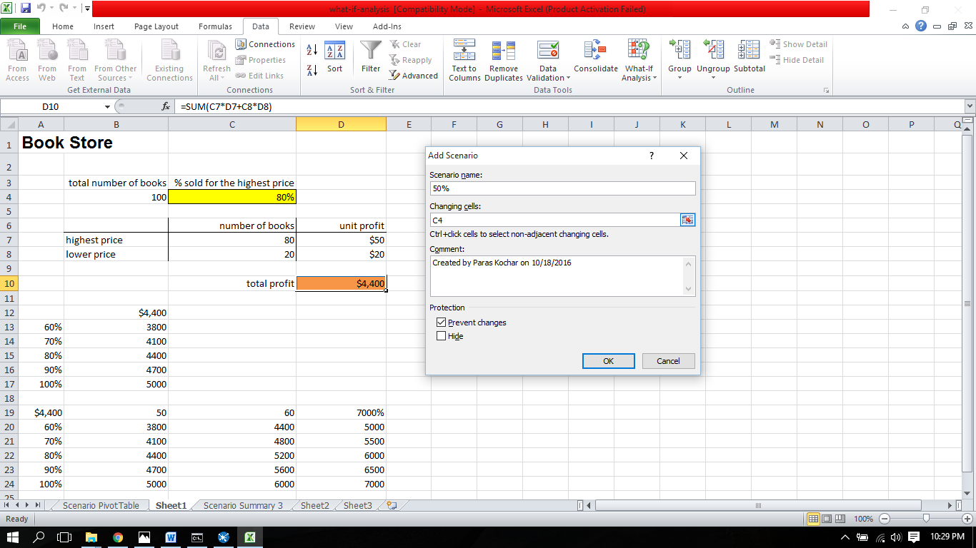

5.Enter values for each changing cell

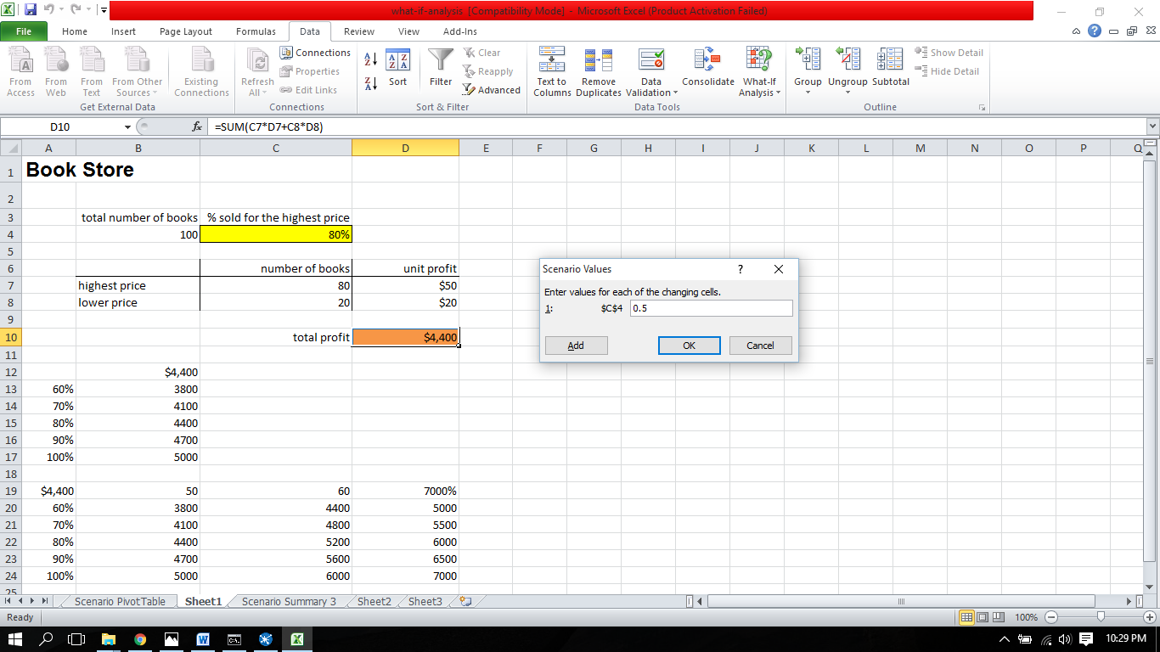

6.Click on the Scenario which you want to take

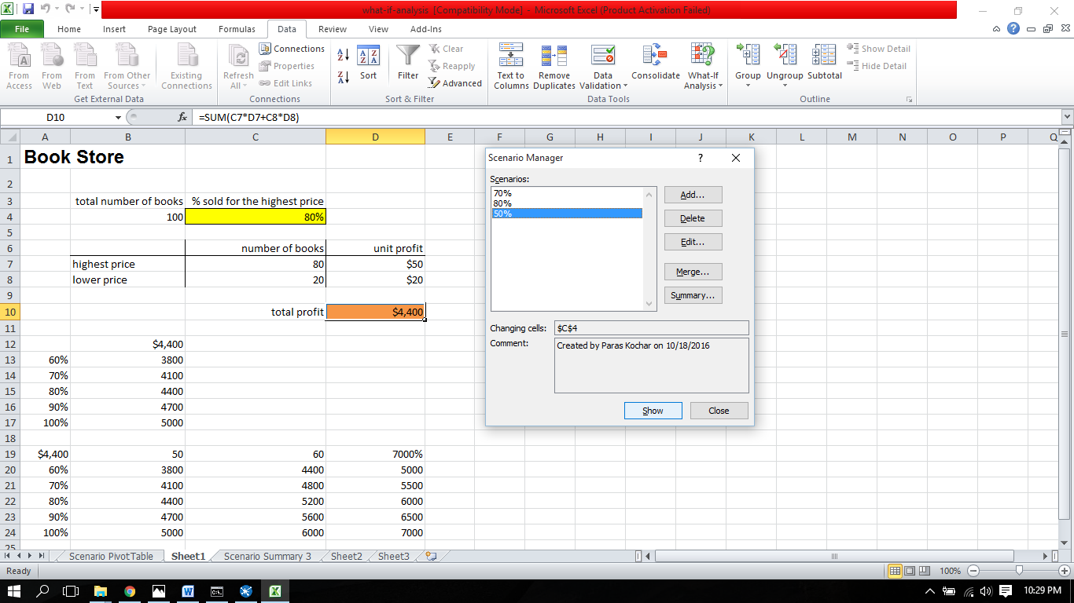

7.Click> Show

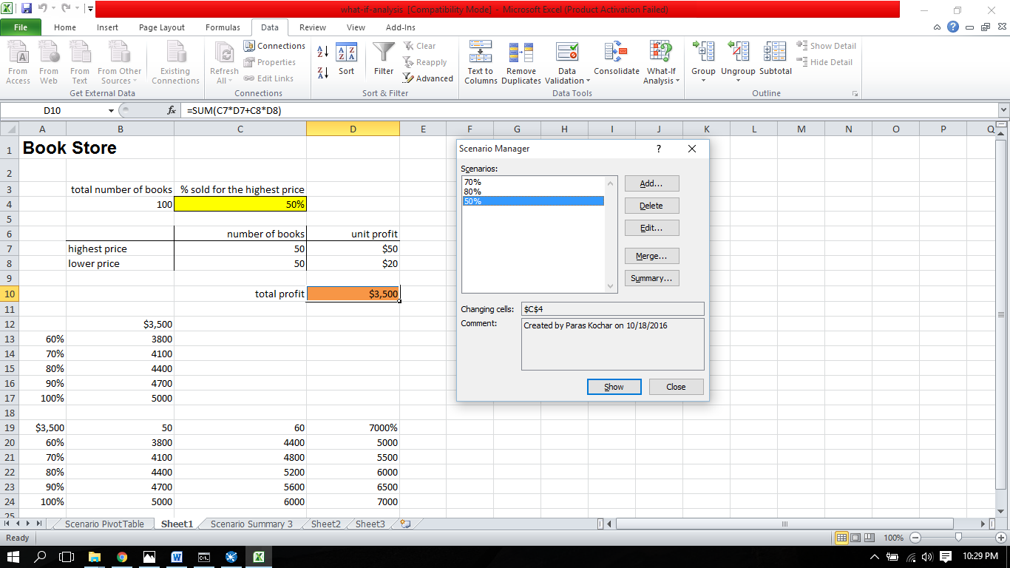

**Goal Seek**

In goal seek one of the value is fixed as a goal and other are automatically changed as per using goal seek.

Steps of Goal Seek

1. Click on goal seek

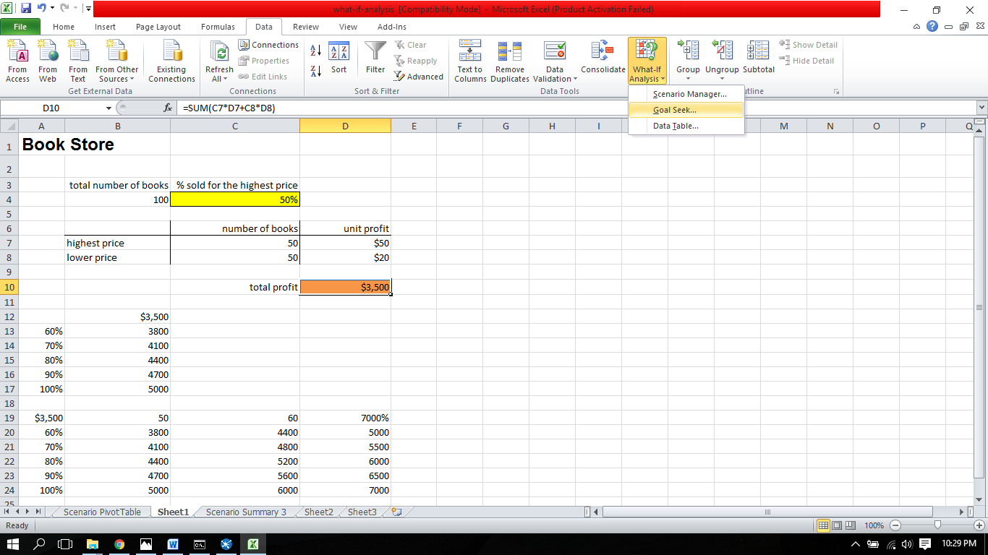

2.Enter set cell > To value > changing cell

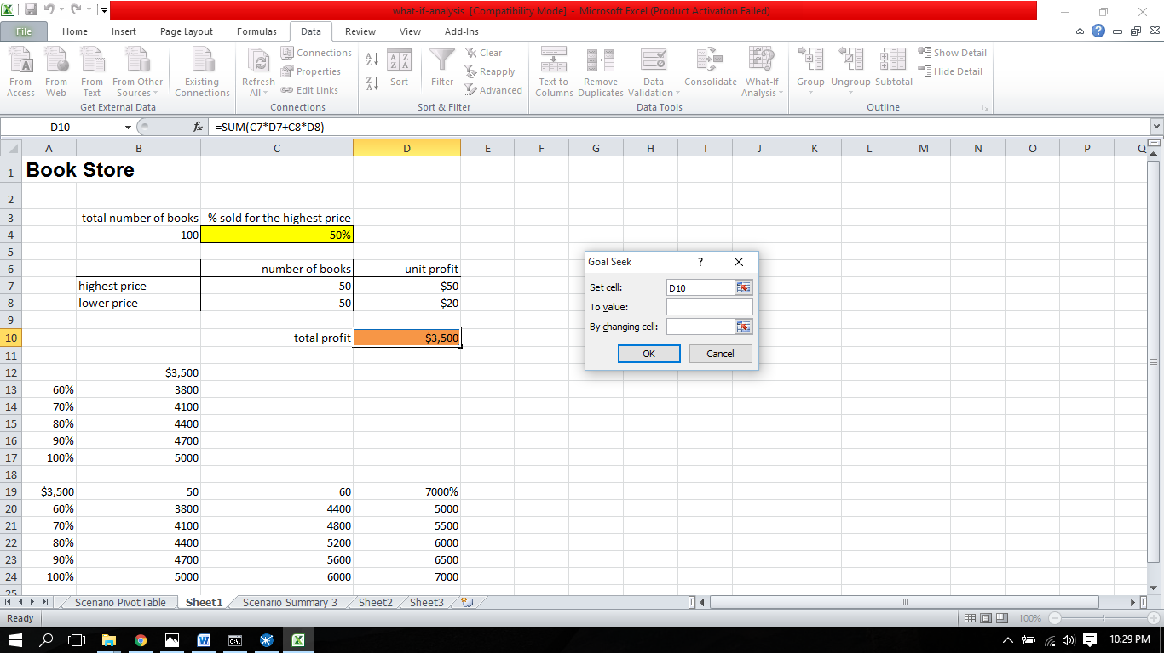

3.Values Entered

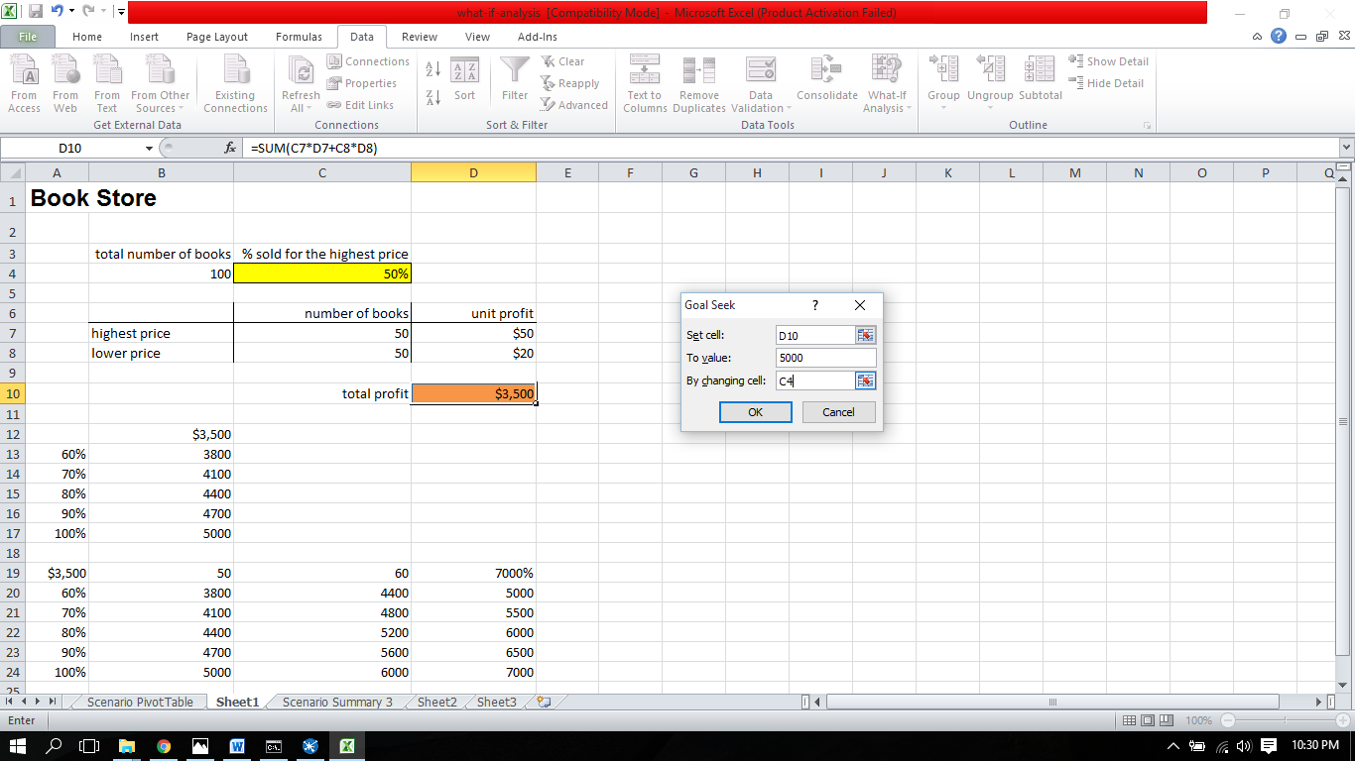

4.Click OK > Goal Seek applied and values are changed

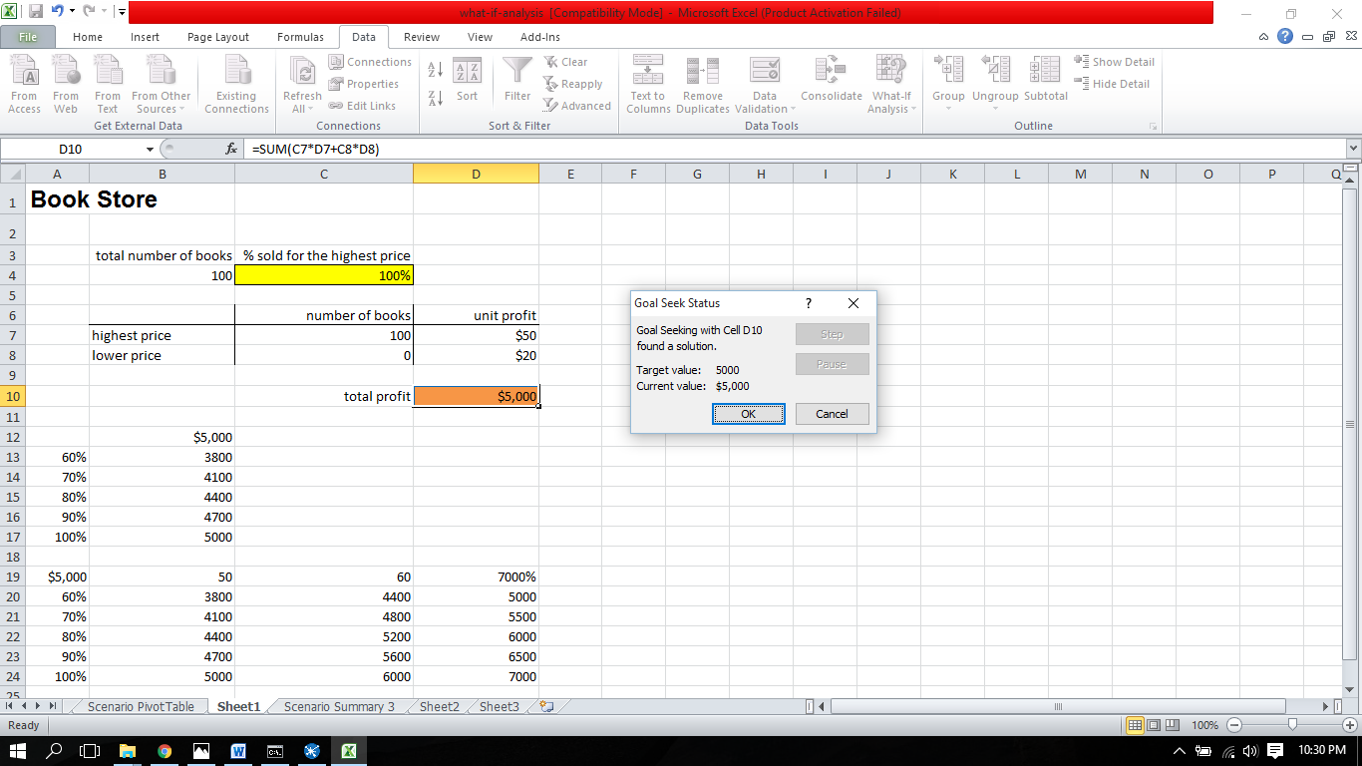

**PRACTICAL NO :5**

**AIM : Data Visualization**

All Pie charts,Graphs,Bars,Lines and their Graphical Representations are under Data Visualization.

1.Select the attributes about which you wants to see the graphical representation>click on specific graph type.

BAR GRAPH

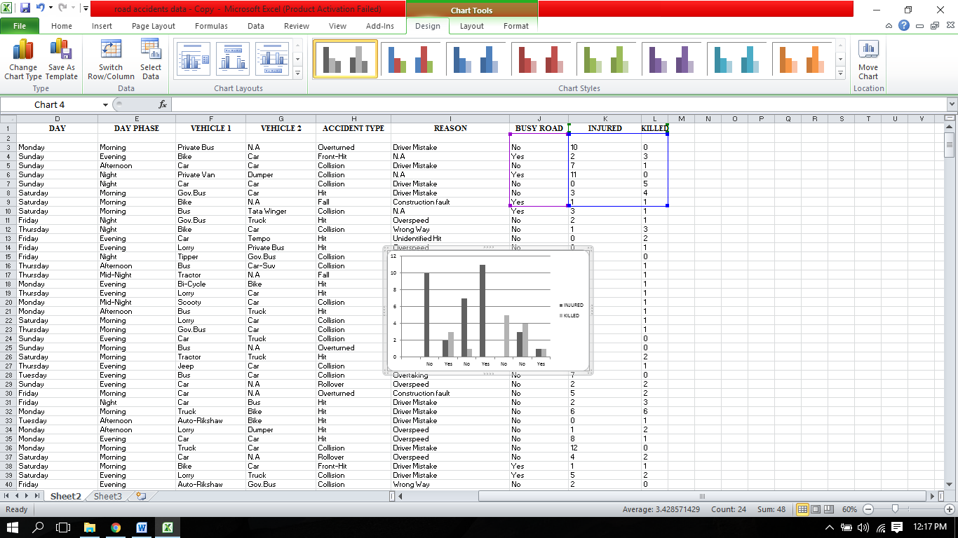

P.T.O

PIE CHART

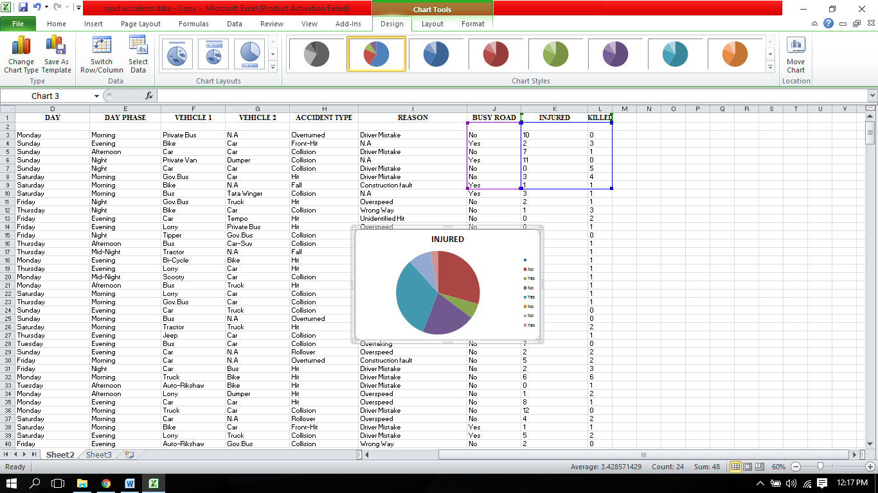

AREA GRAPH

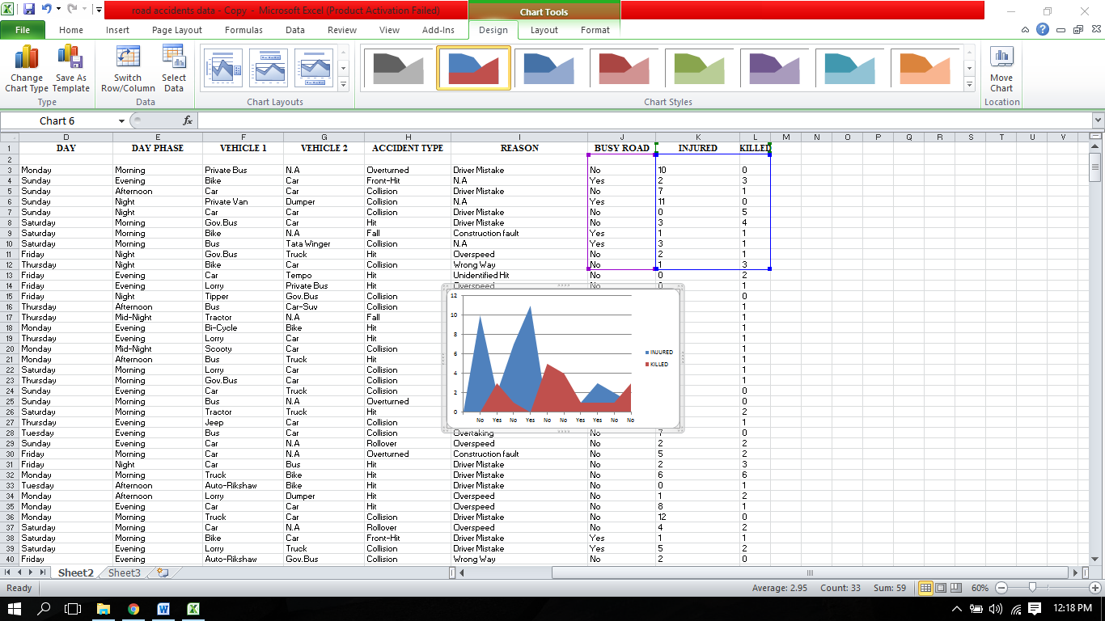

**PRACTICAL NO:6**

**AIM: Data Slicing and Dicing**

**Slicing:-**1.Open Northwind_Traders file>Click on insert >click slices>select the slice according to which you want to see the file>Click OK.

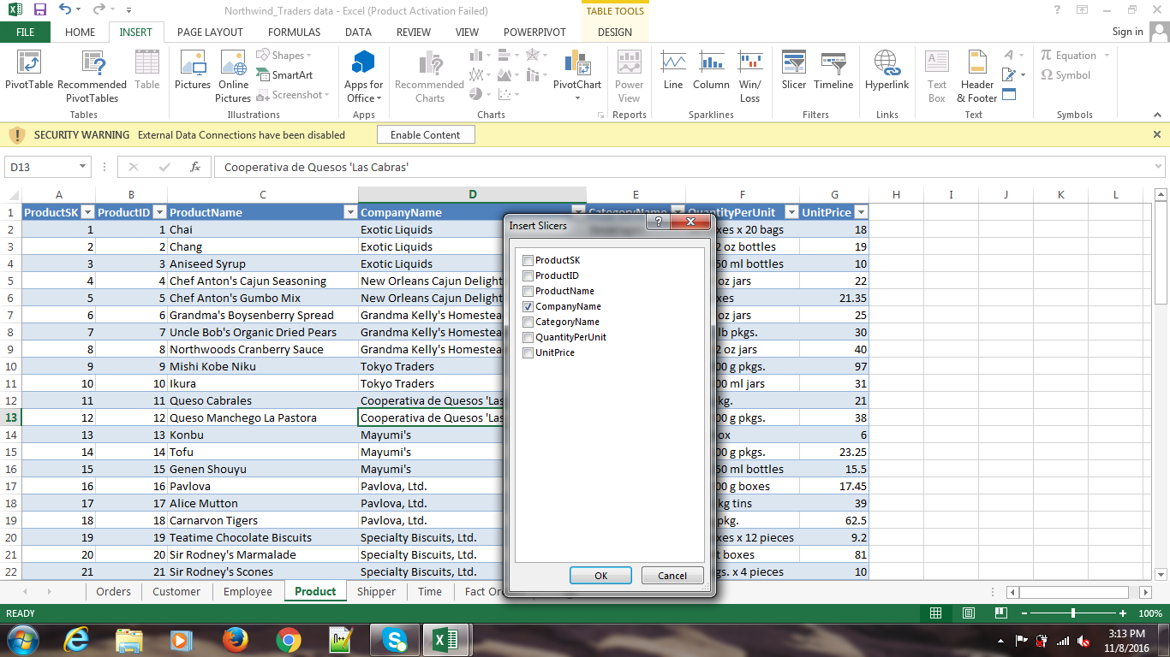2.From the selected slice select the attribute for the next view you want IE. C_name:Cooperative

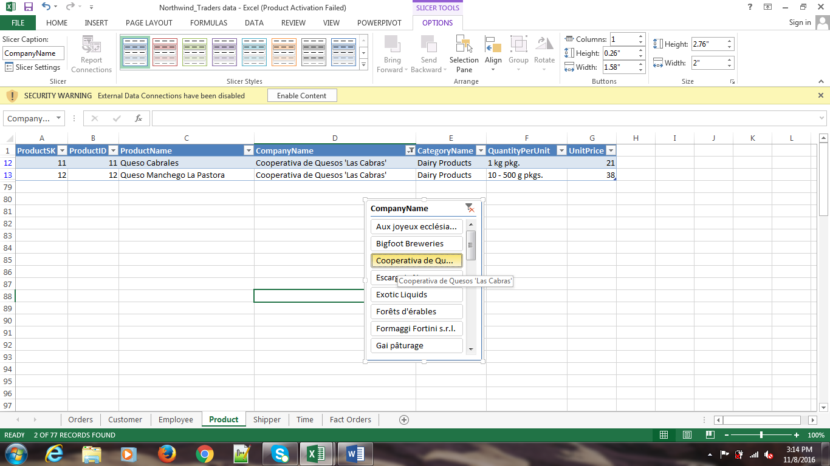

3.From the selected slice select the attribute for the next view you want. IE. C_name: Formaggi

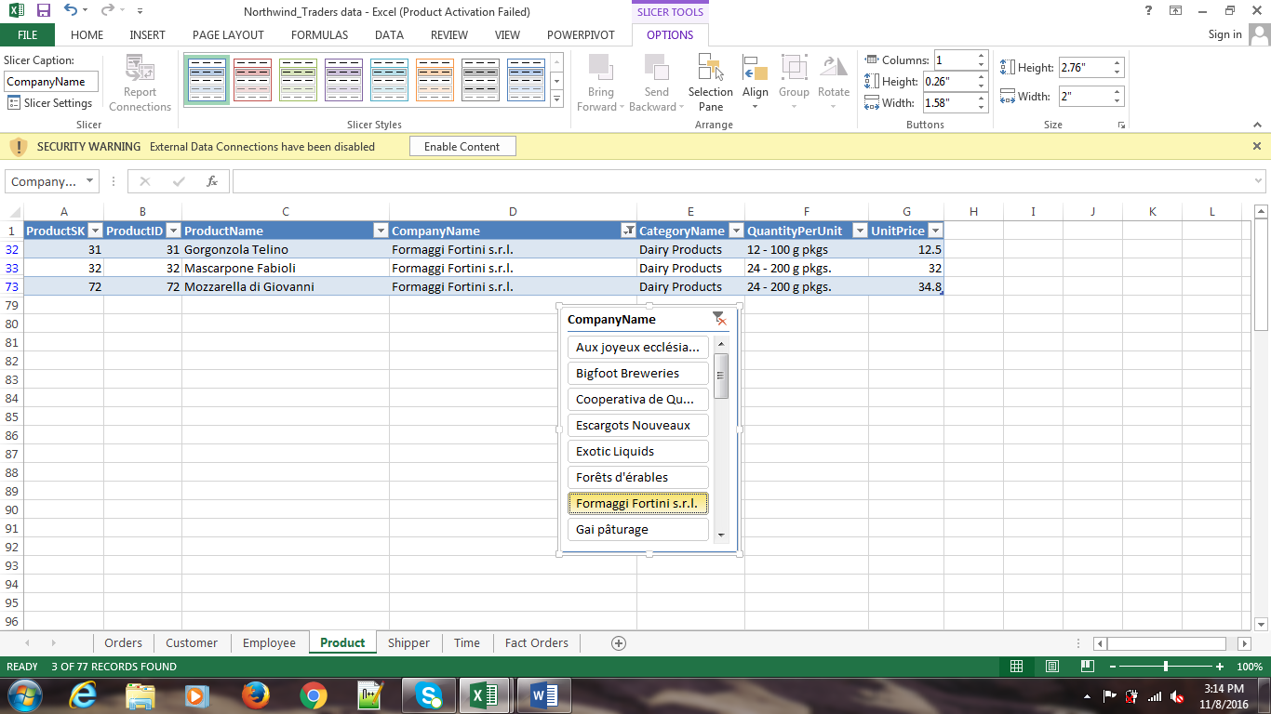

**Dicing:-**

1.Click insert >Click slices>If you select multiple columns the it will create a multiple column vies called dice>select values>click OK.

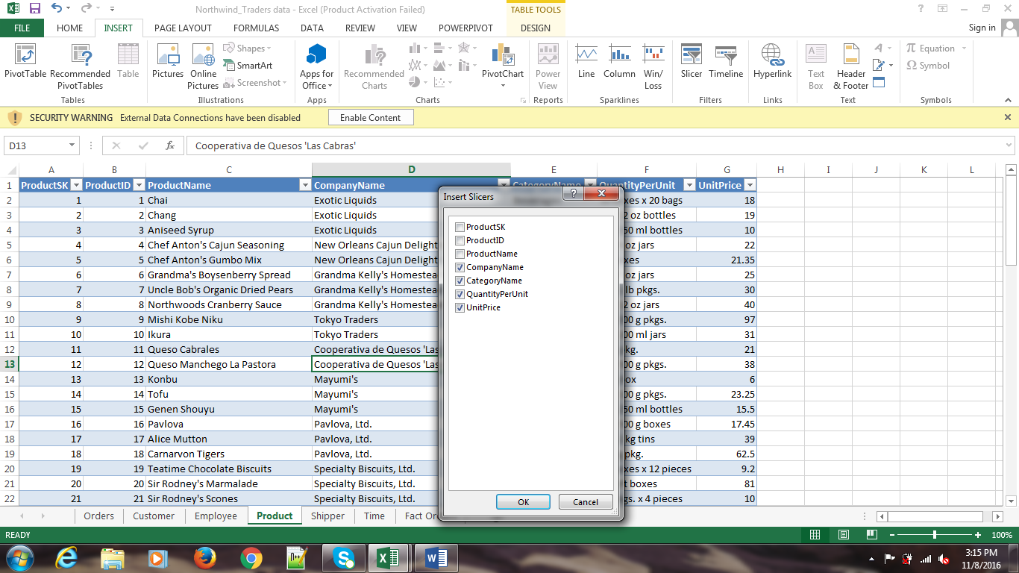

2.Select further specific attributes from all the selected columns which you want.

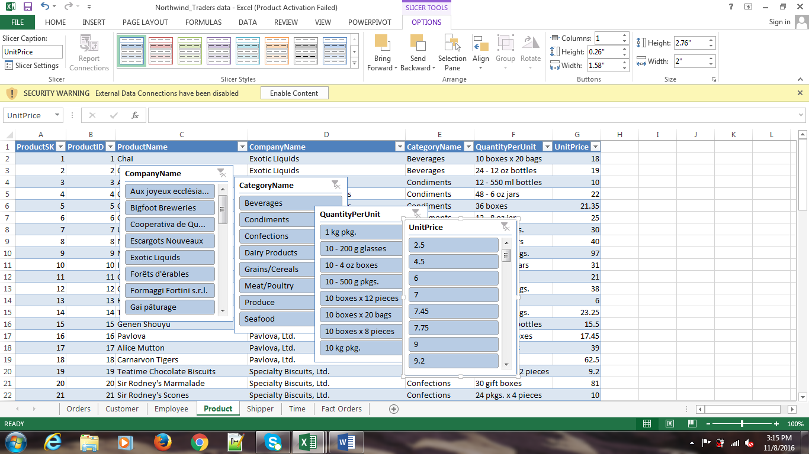

3.Dice View of Selected Columns.

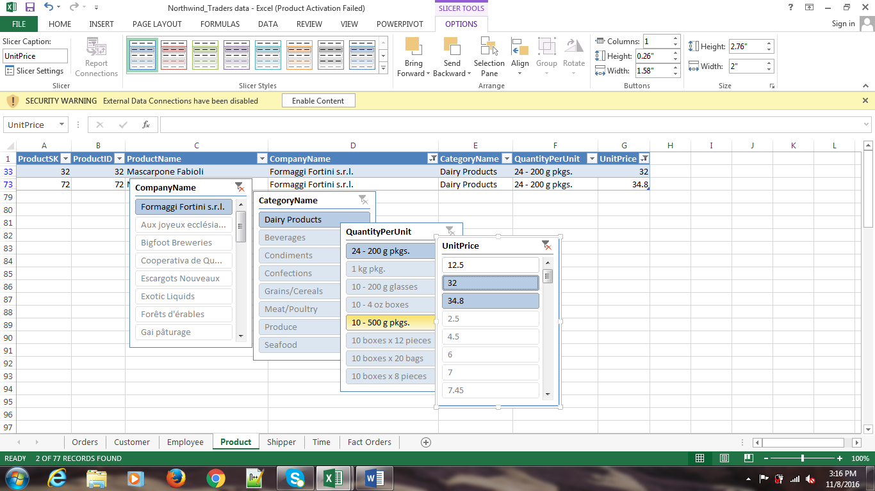

**PRACTICAL NO: 7**

**AIM: Creation of Repository**

REPOSITORY

Spoon allows you to store transformation and job files to the local file system or in the Kettle repository. The Kettle repository can be housed in any common relational database. To load a transformation from a database repository, you must connect to this repository. Define a database connection to the repository when you start Spoon.

STEPS TO CREATE DI REPOSITORY CONNECTION:

1. Click on **Tools > Repository > Connect**

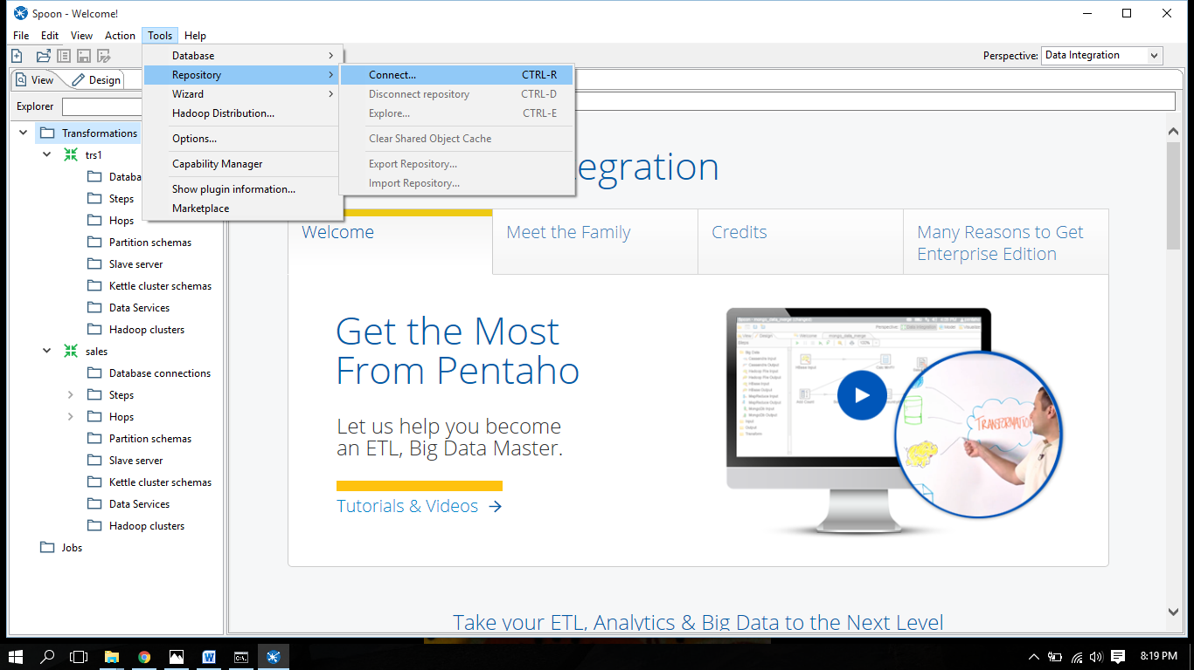

1. The **Repository Connection** dialog box appears.
2. In the **Repository Connection** dialog box, click the add button (+).
3. Select DI Repository **>**DI Repository and click OK. The Repository Configuration dialog box appears.

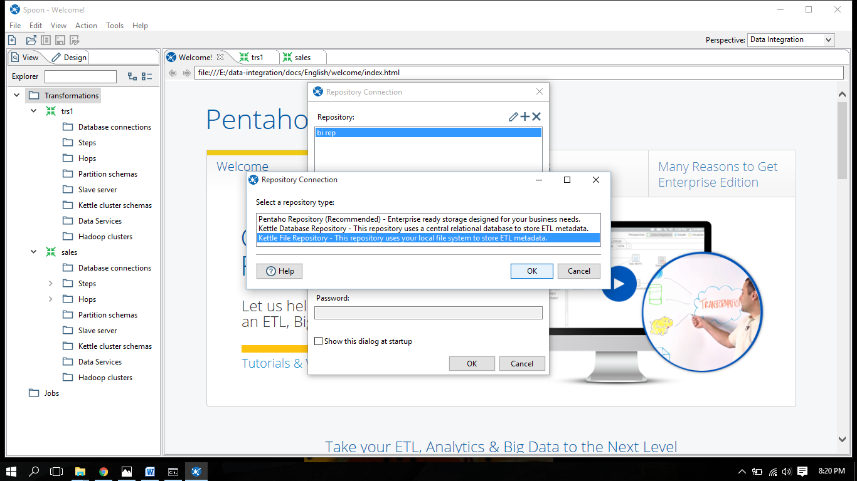

1. Select the Repository root directory .

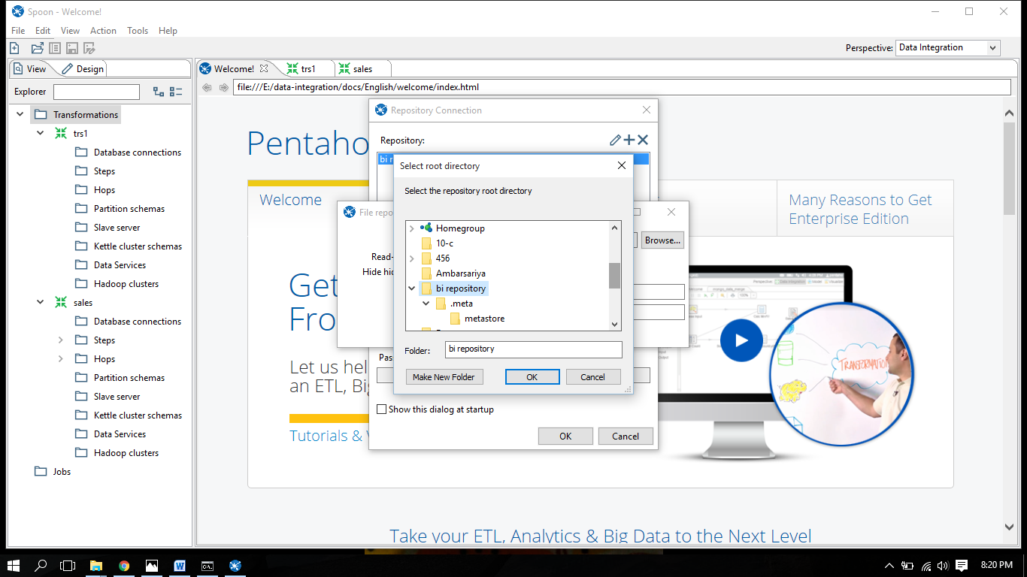

1. “ File Repository Settings dialogue” box will appear > browse base directory > name of the repository > description(optional) > click ok

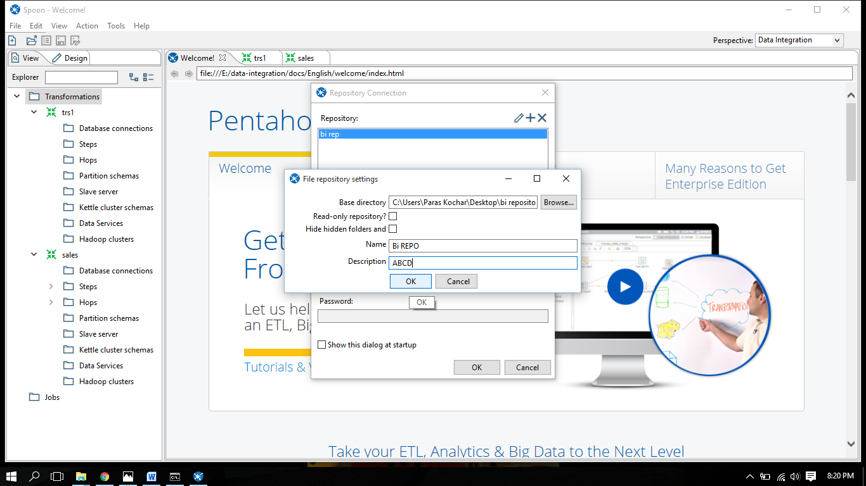

1. Click **OK** to exit the Repository Configuration dialog box. Your new connection appears in the list of available repositories.

.

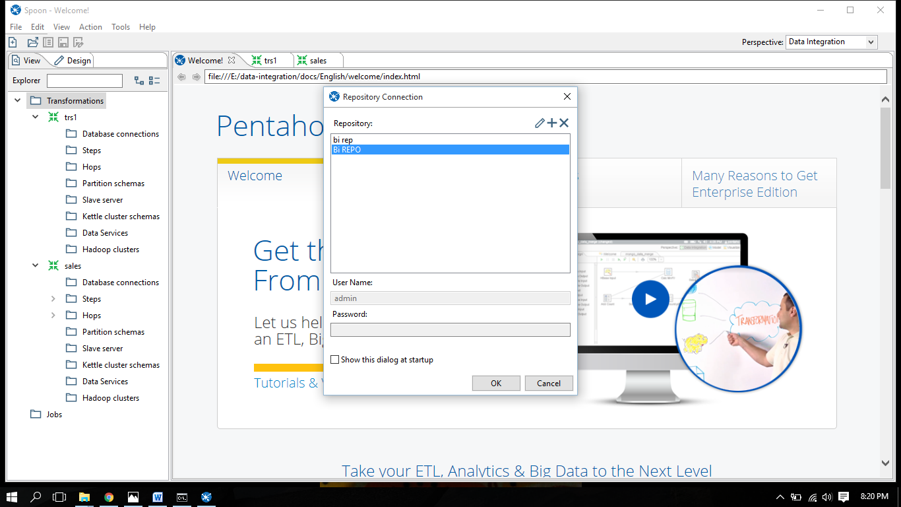

STEPS TO DISCONNECT THE REPOSITORY CONNECTION :

1. Save all open files.
2. Selec Tools > Repository > Disconnect Repository.

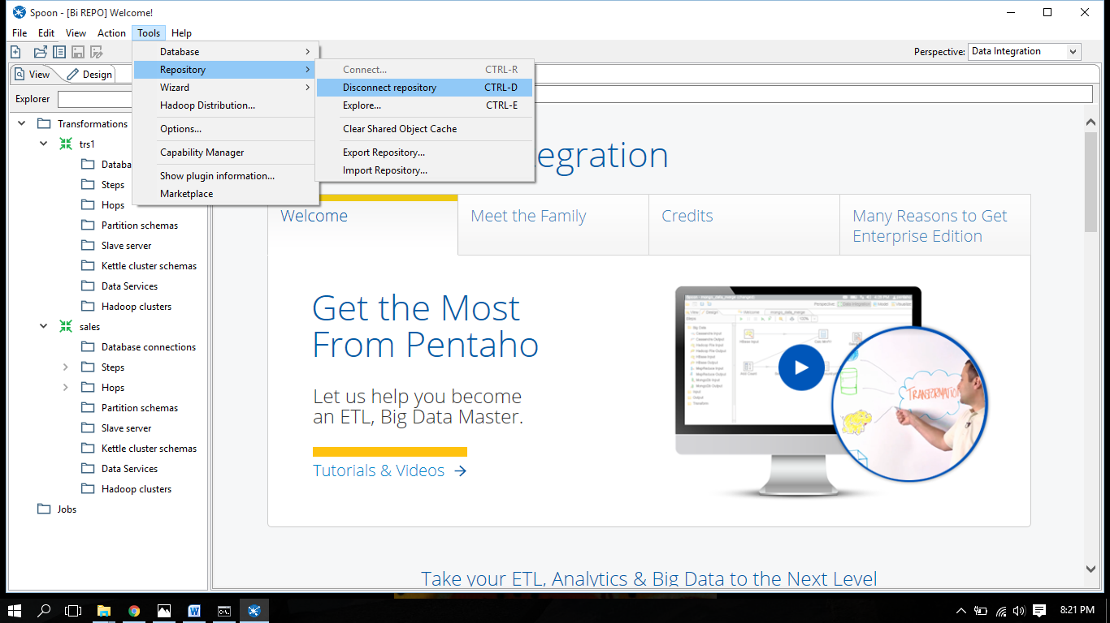

**PRACTICAL NO: 8**

**AIM: Conversion of Files**

In Pentaho we can convert one type of file format to another type of file format. Following are the different types of file format converted into different formats.

Text File To Excel File

STEPS TO CONVERT:

1.Click on **Text Input File**

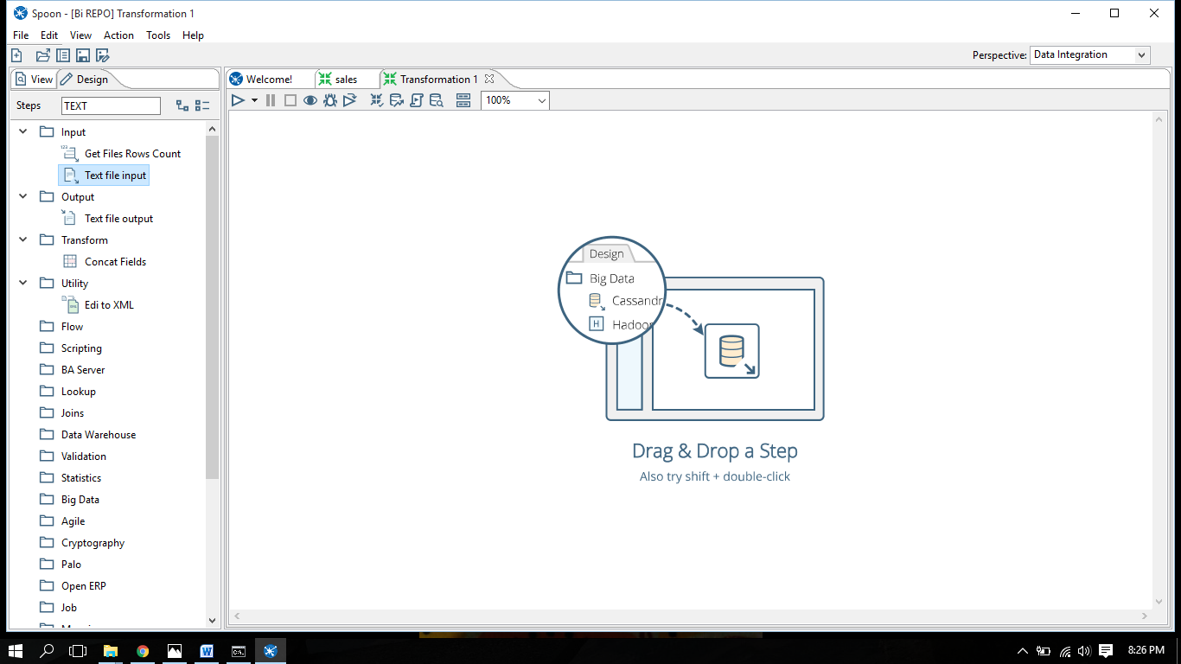

2.Drag it To Transformation Window

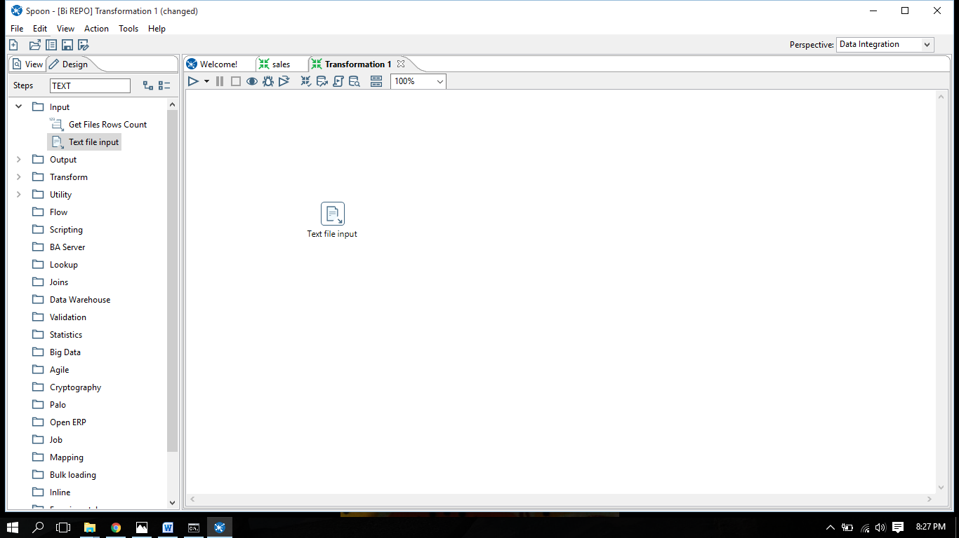

3. Click on Excel output file

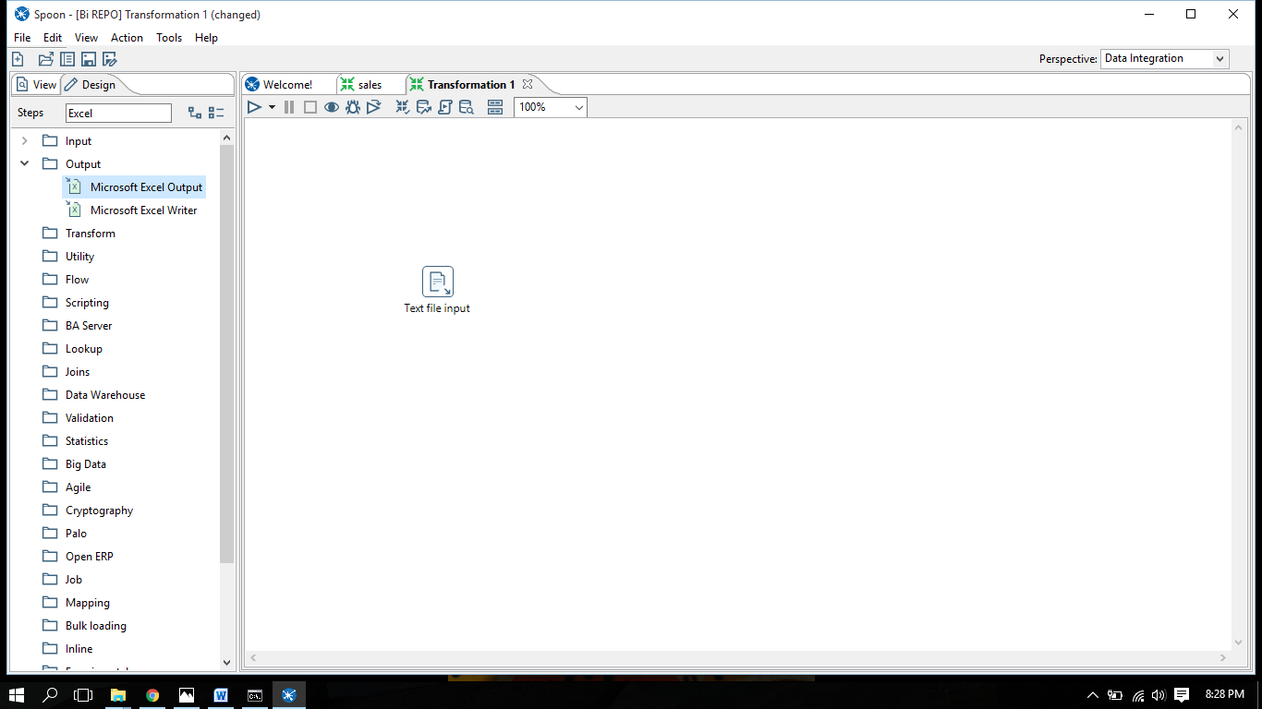

4.Drag it to the Transformation Screen

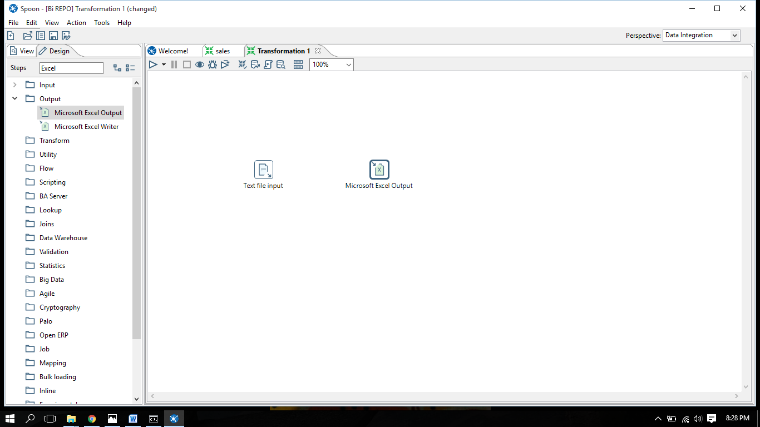

5.Click on Text Input File a Dialog Box will appear.

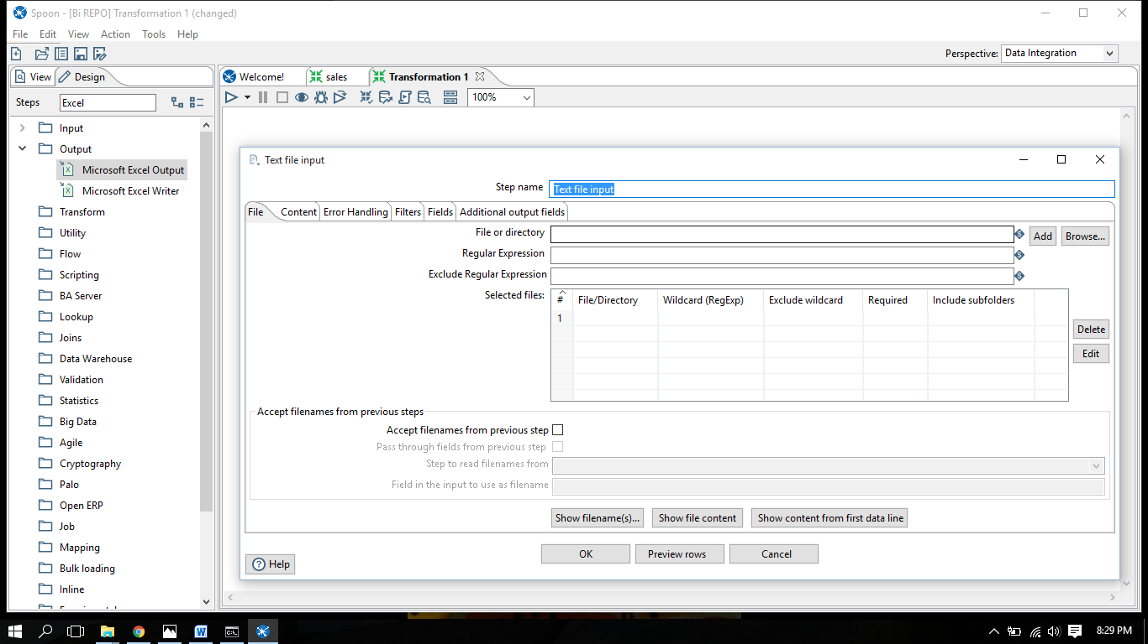

6. Click on browse and select file to be opened in this.

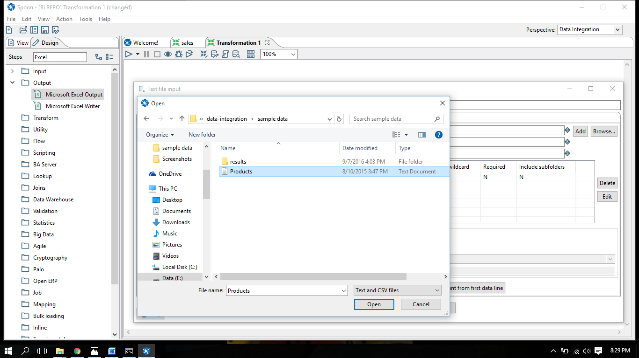

7. Click On the file and then click on add

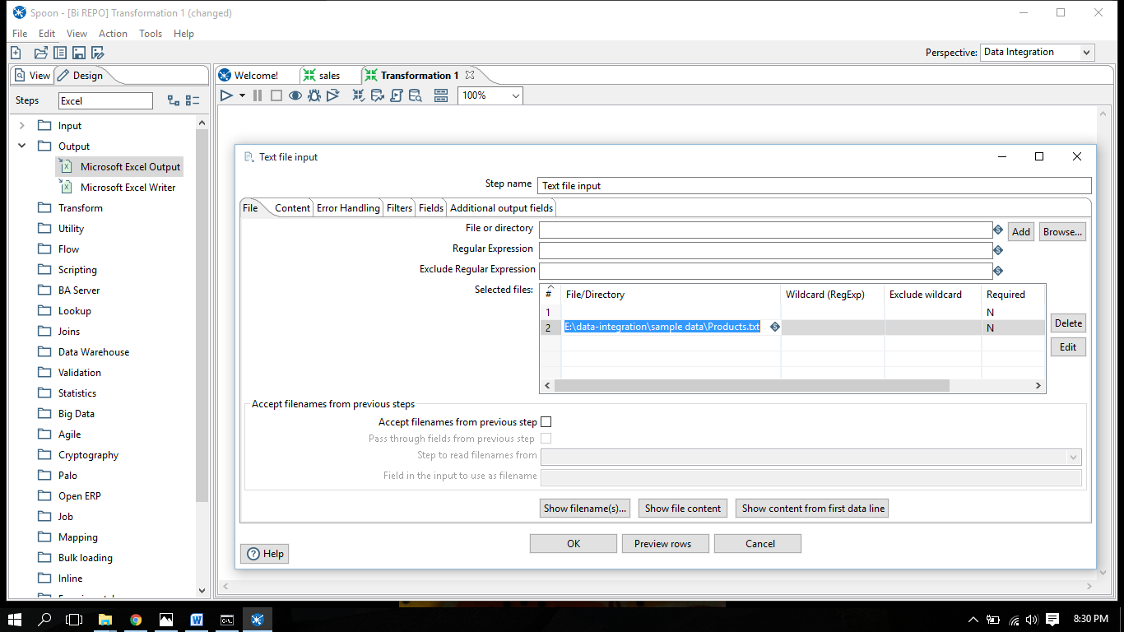

8.Click On show file content

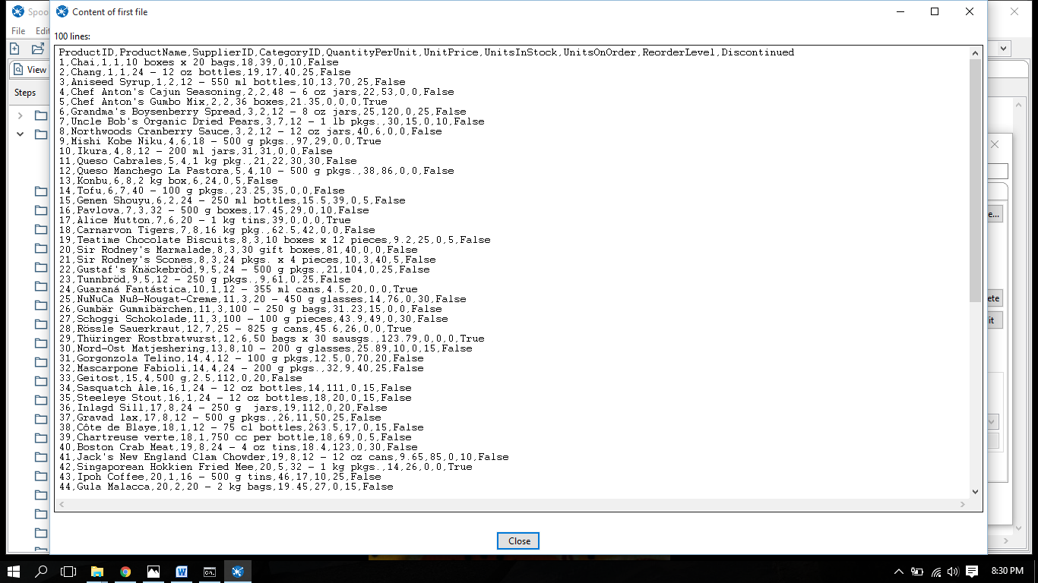

9.Click on preview rows

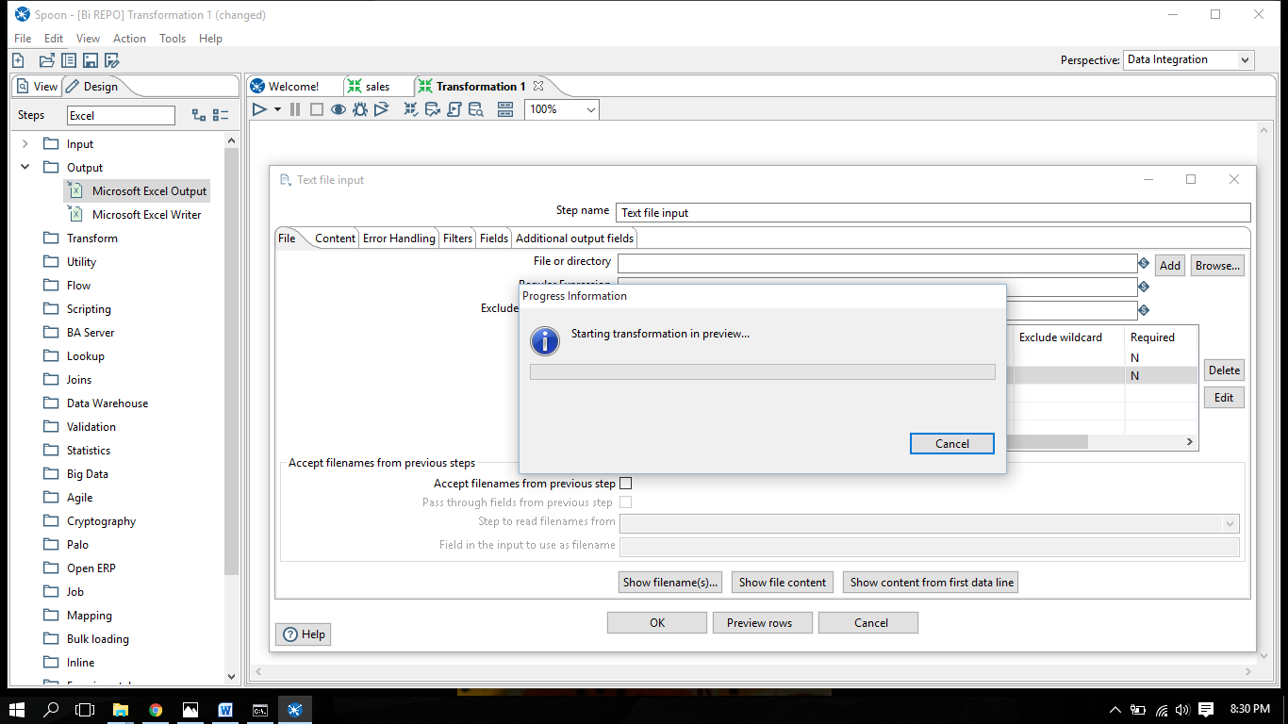

10.Examine the preview data

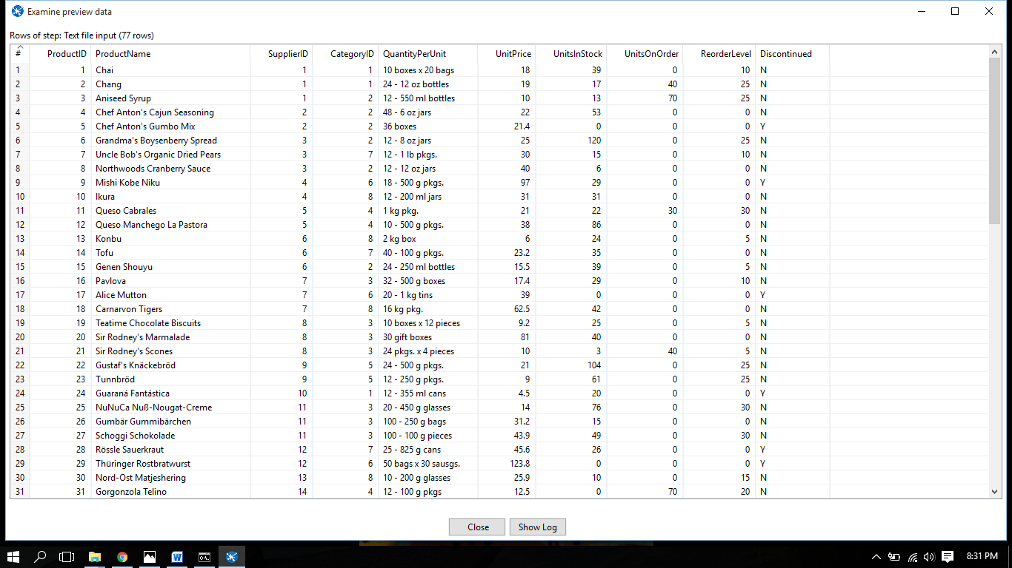

11.Click on the text input output connector hop

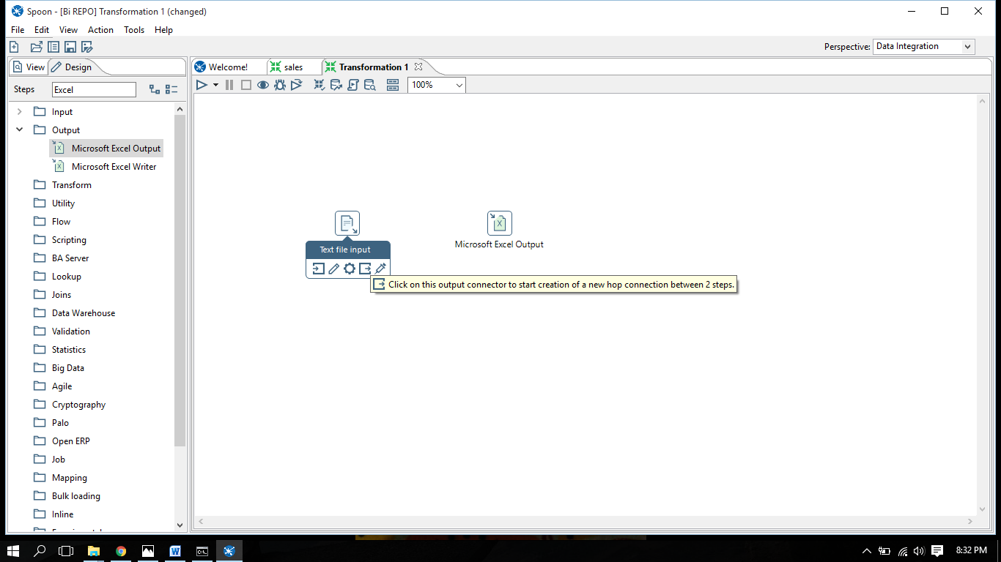

12.Drag the connector to the output file and click on it

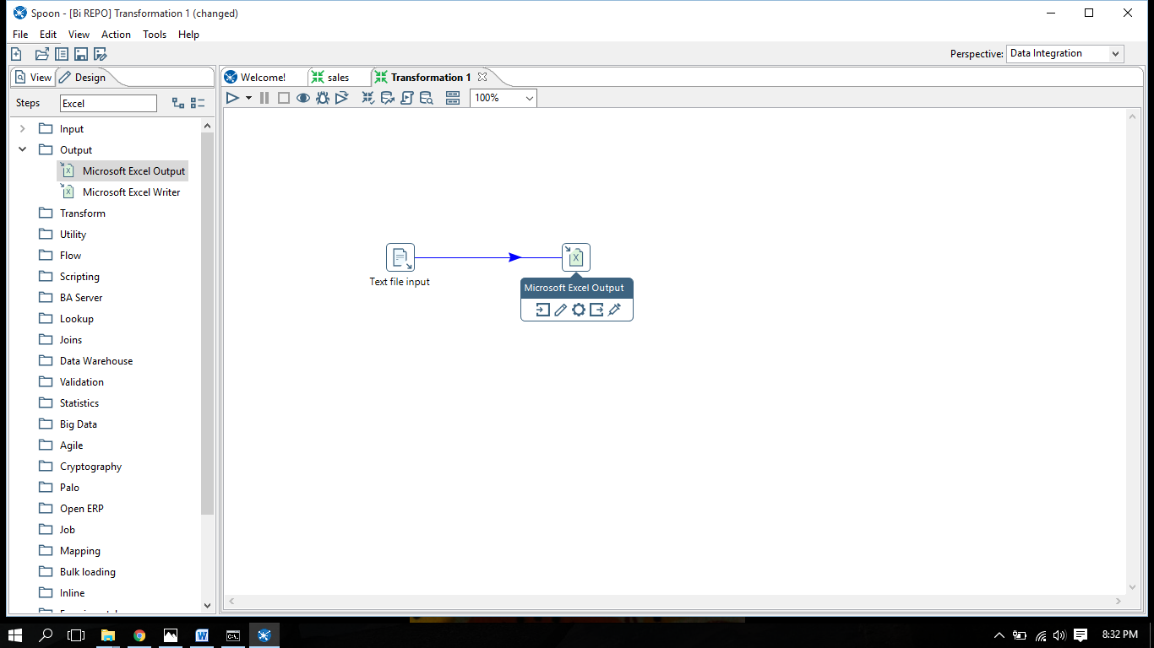

13.Click on the Output file

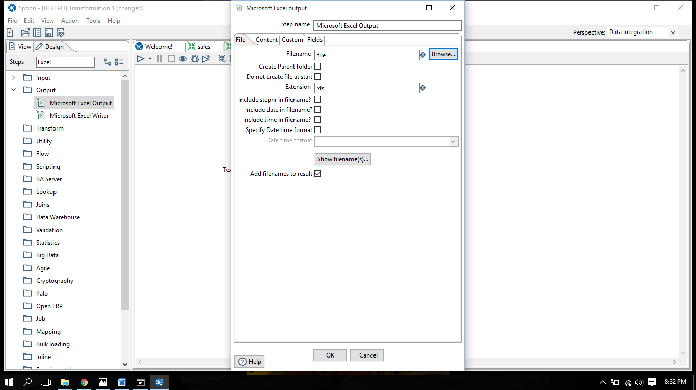

14.Click on browse and give a name to file where u want to save it

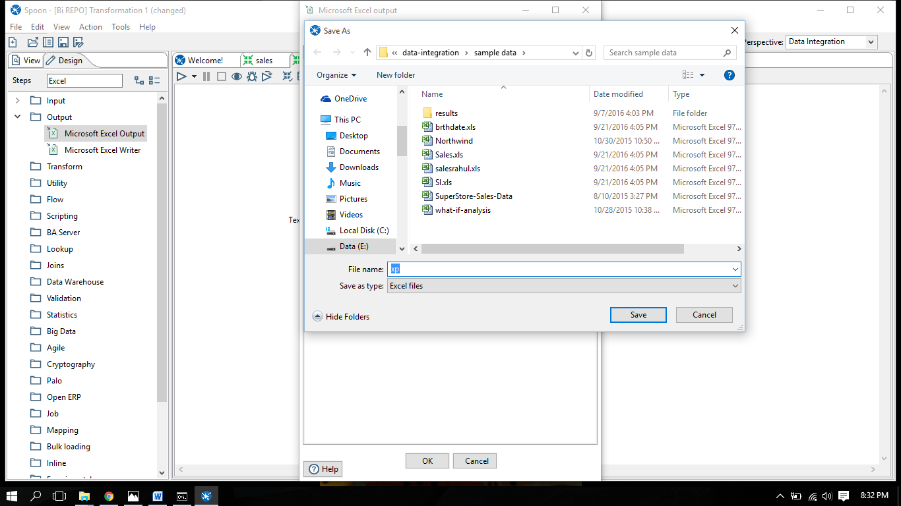

15.Click on get fields

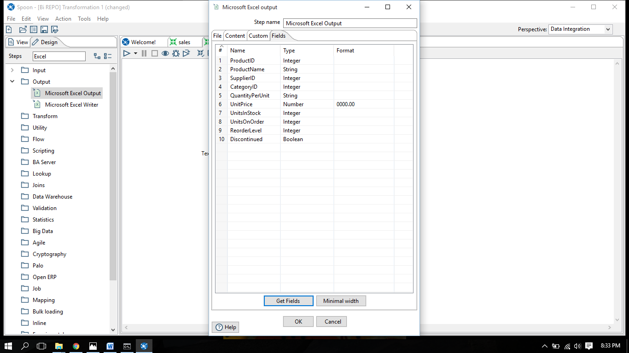

16.Now move to the left upper corner of the screen Click on play Icon a dialog box will appear

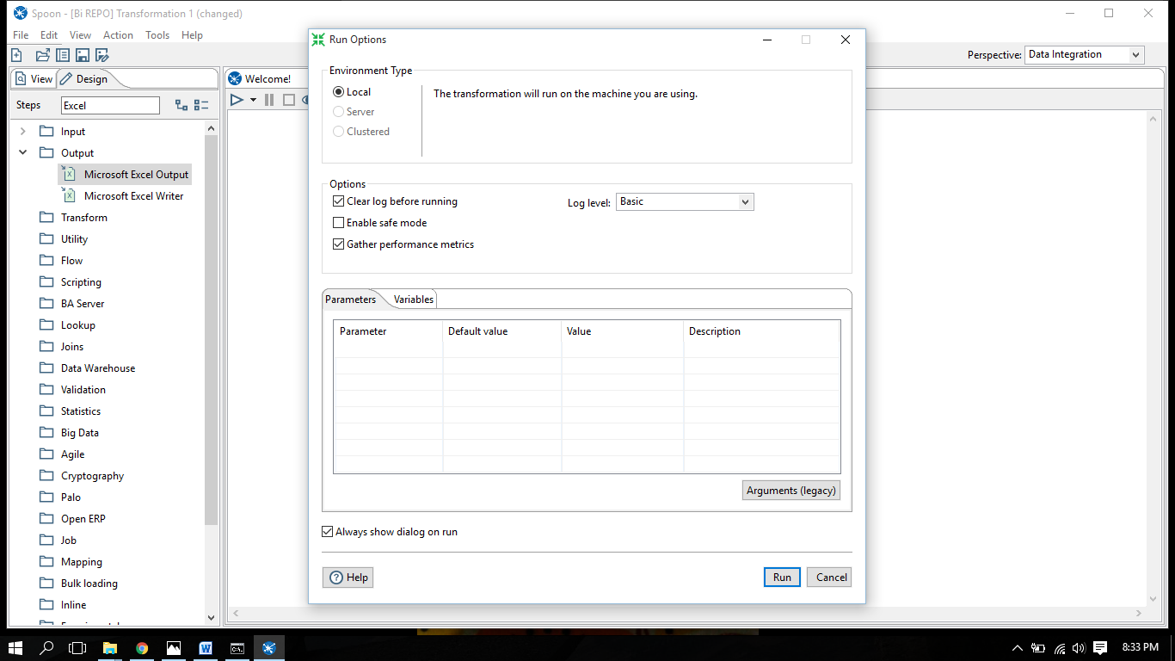

17.Click on Run then it require a name for transformation

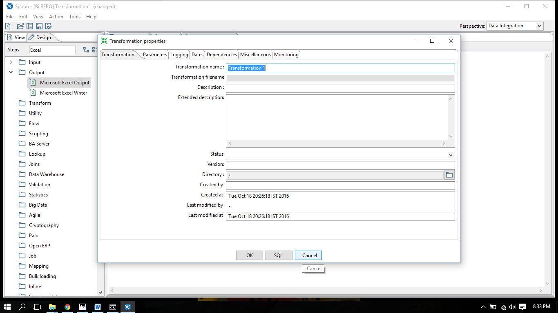

18.If green signs appear on screen then your file is converted.

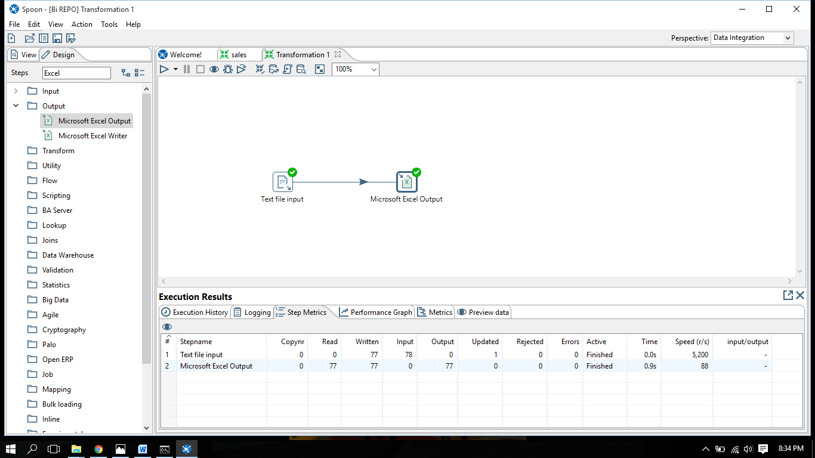

**PRACTICAL NO: 9**

**AIM: Filter the File and Give the Output-row filter**

ROW FILTERS: The Filter Rows step allows you to filter rows based on conditions and comparisons**.** Once this step is connected to a previous step (one or more and receiving input), you can click on the "<field>", "=" and "<value>" areas to construct a condition.

1.All the records whose ship mode starts with Regular.

1. Input file

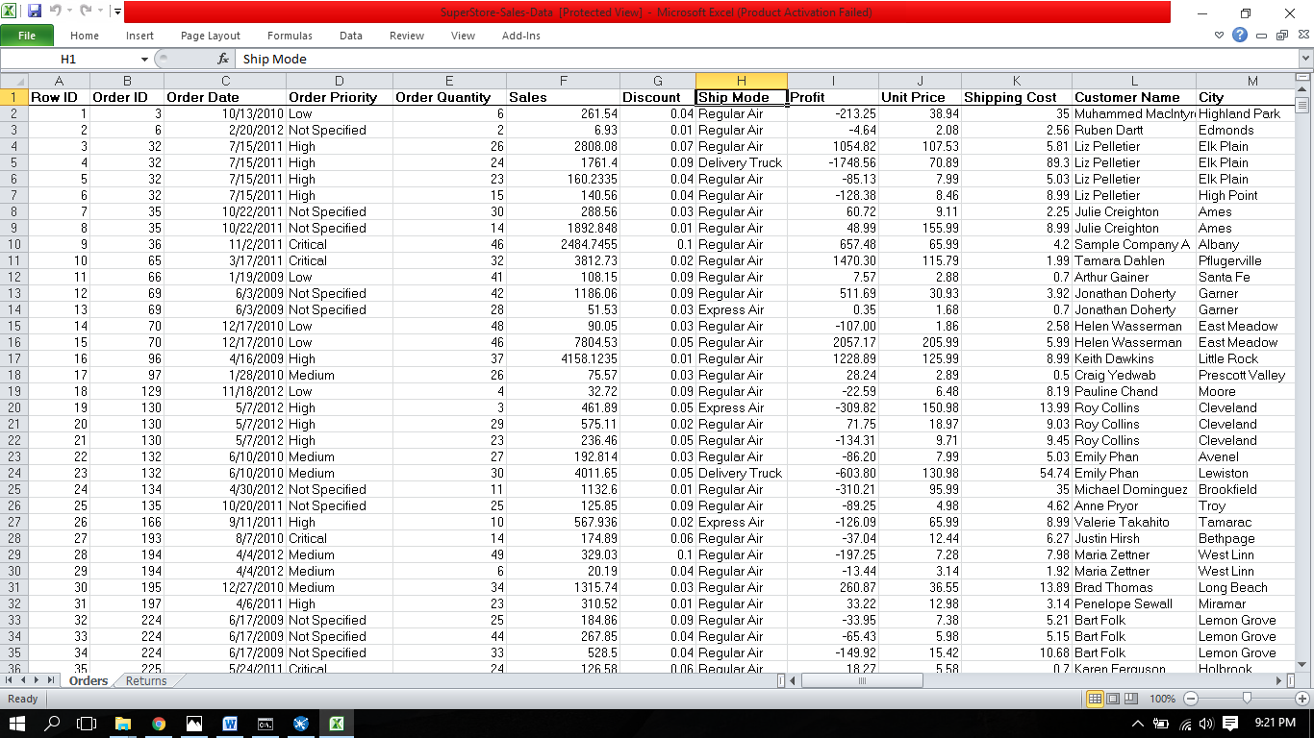

1. Go to **design< input < Microsoft excel input**

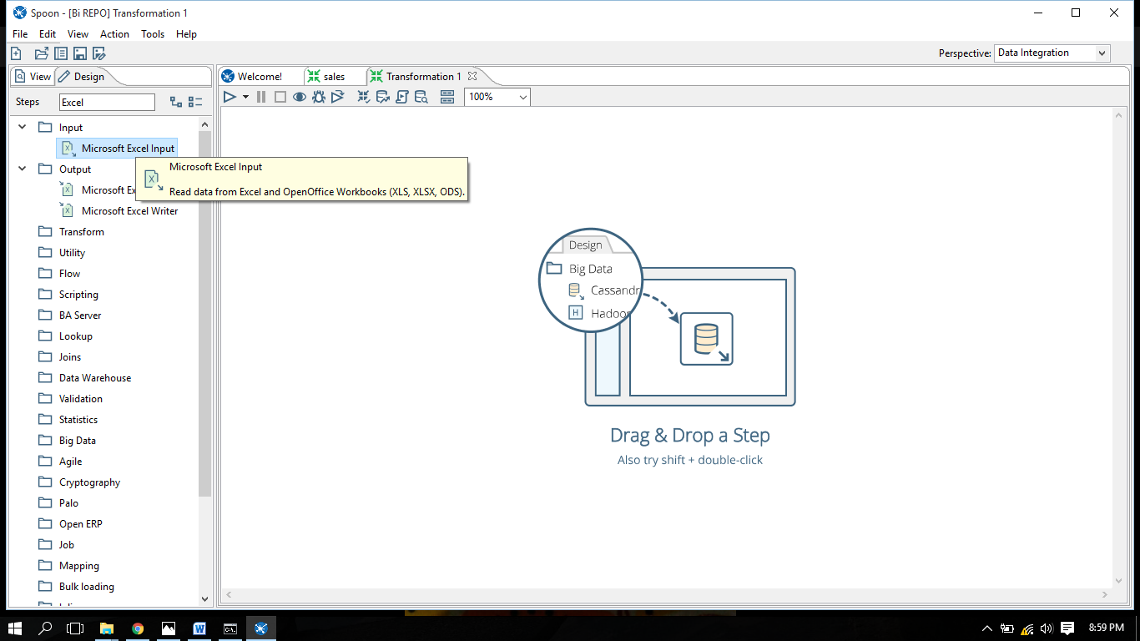

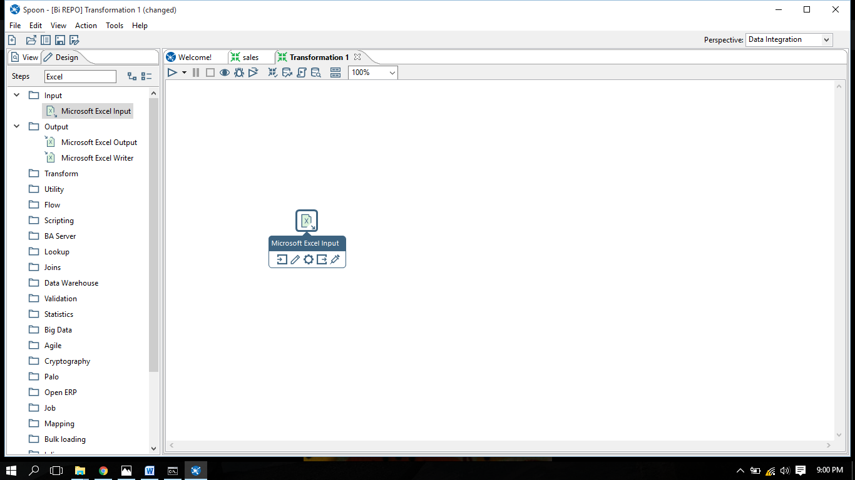

1. Go to filters < filter rows

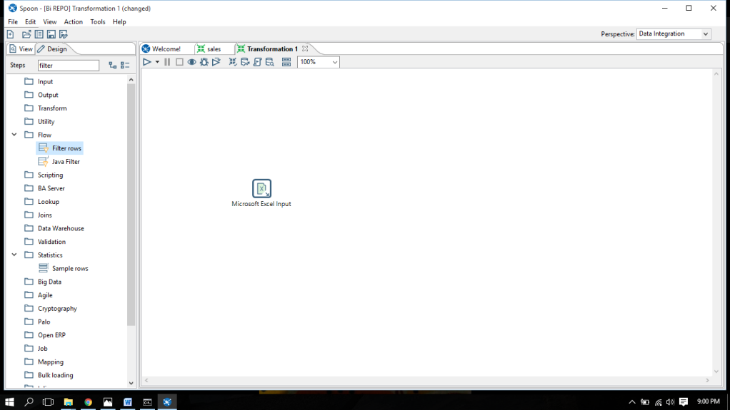

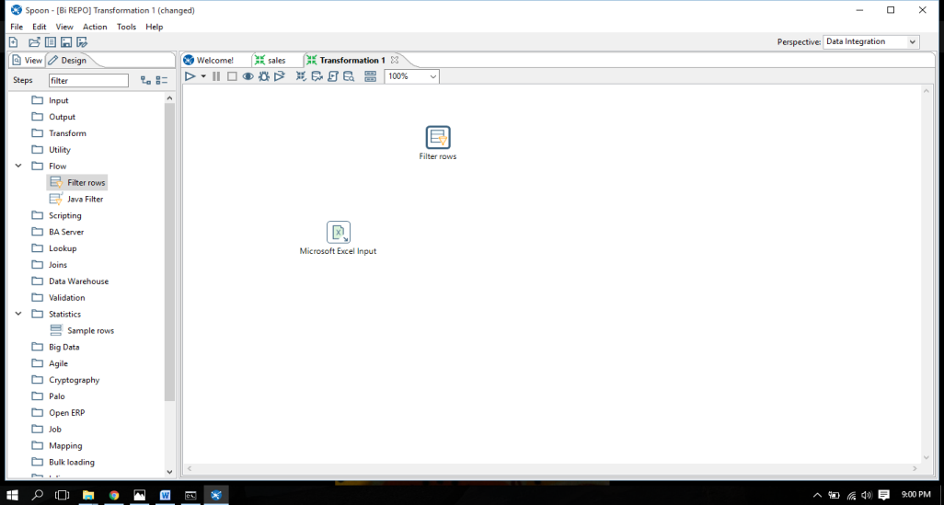

1. From output drag Microsoft excel output

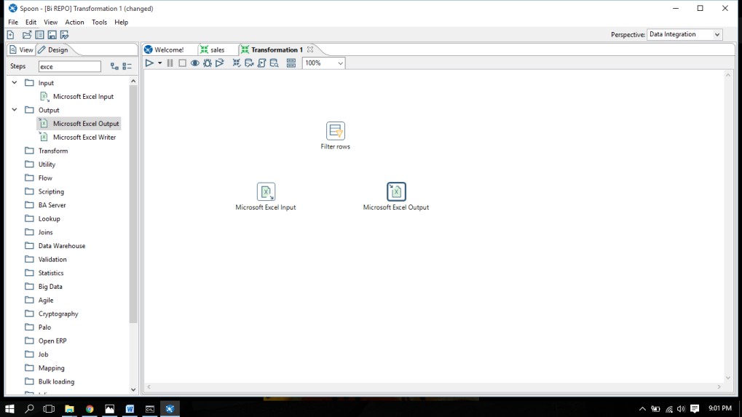

1. Click browse, a dialogue box will appear.

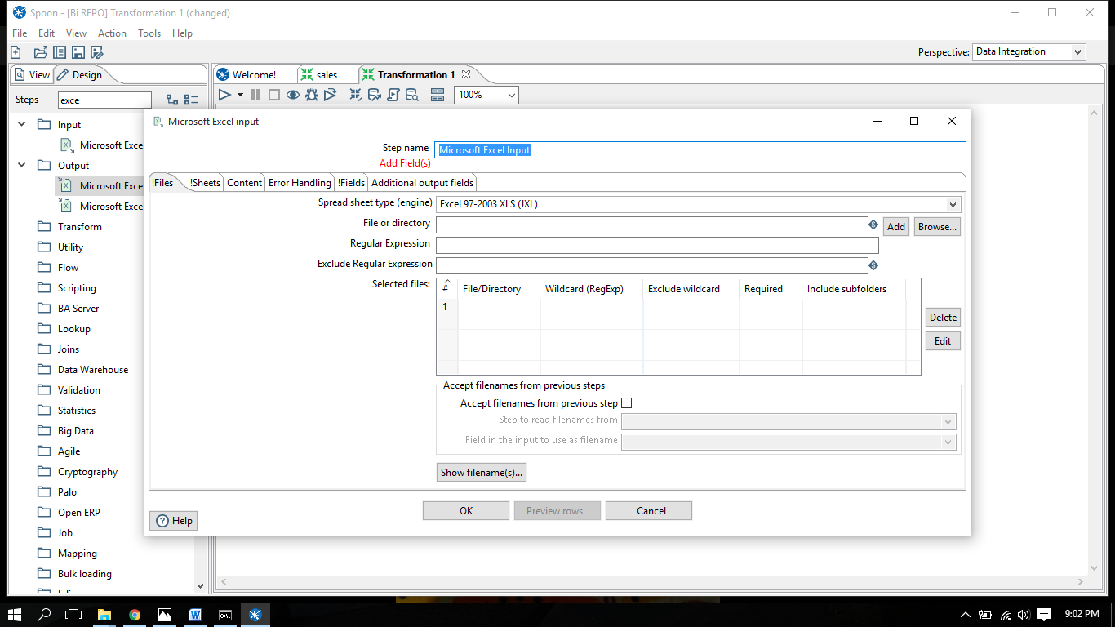

1. Select file you want to add .

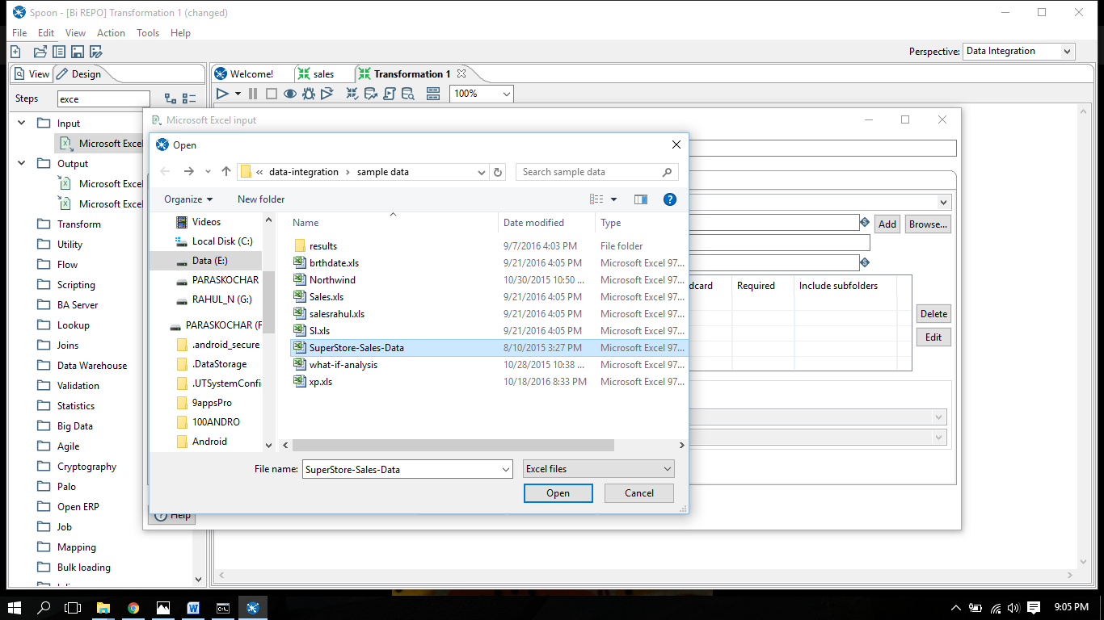

File is added in database

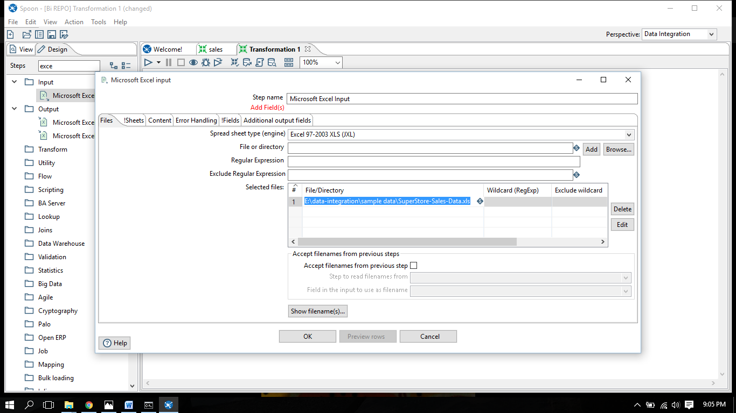

1. Get sheet name > click OK.

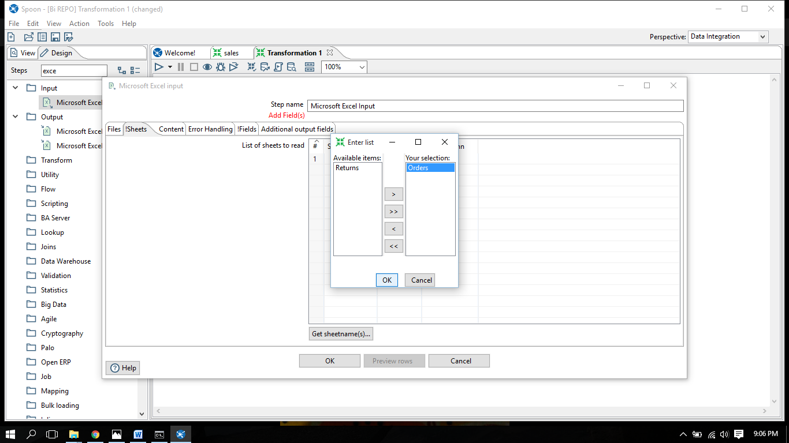

1. Click sheet name > click get field name

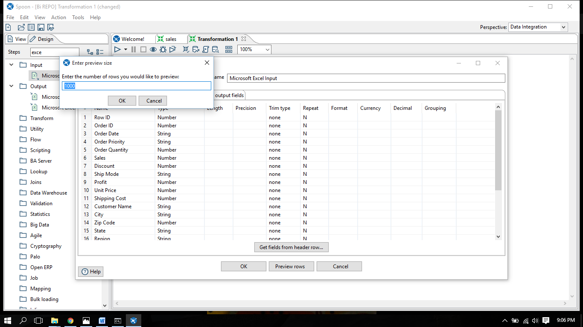

1. Click preview rows > examine preview data

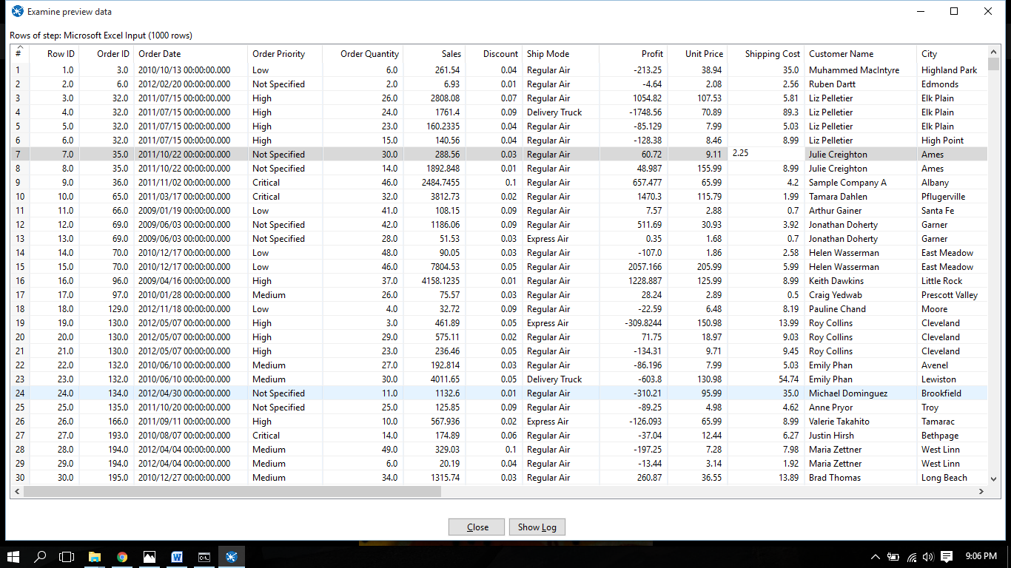

1. Make connection of input file via row filter with output file.

In row filter we‘ll give the required conditions .

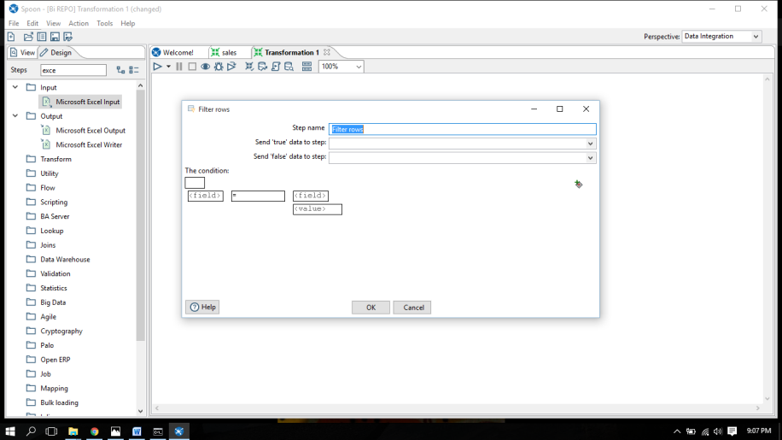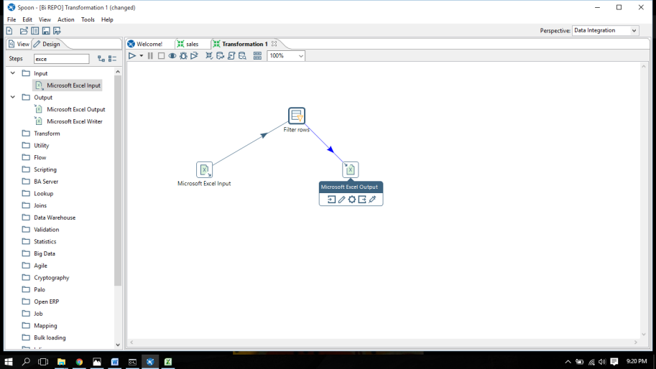

1. Browse for filename where you want to save the file , click OK. > get fields > run > give transformation name > click OK

REQUIRED OUTPUT : -

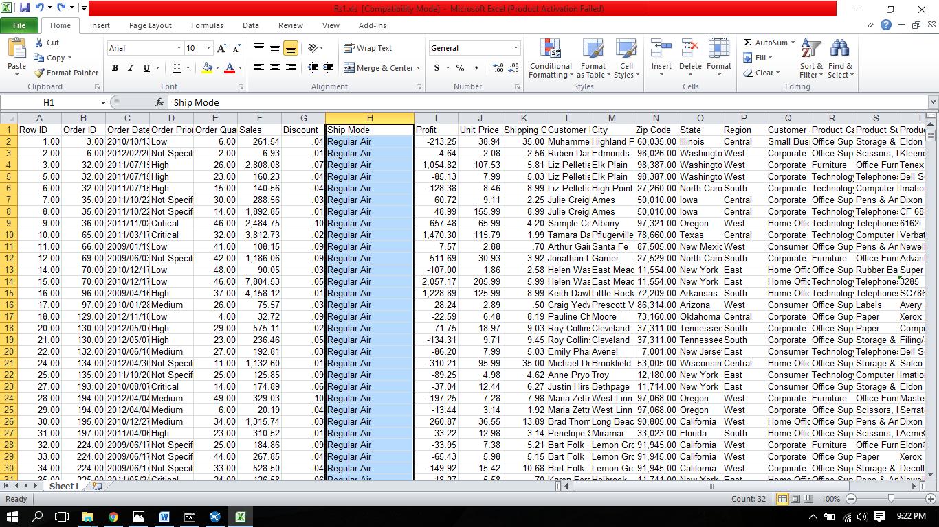

2. All the records where ship mode ends with Air.

CONDITION:

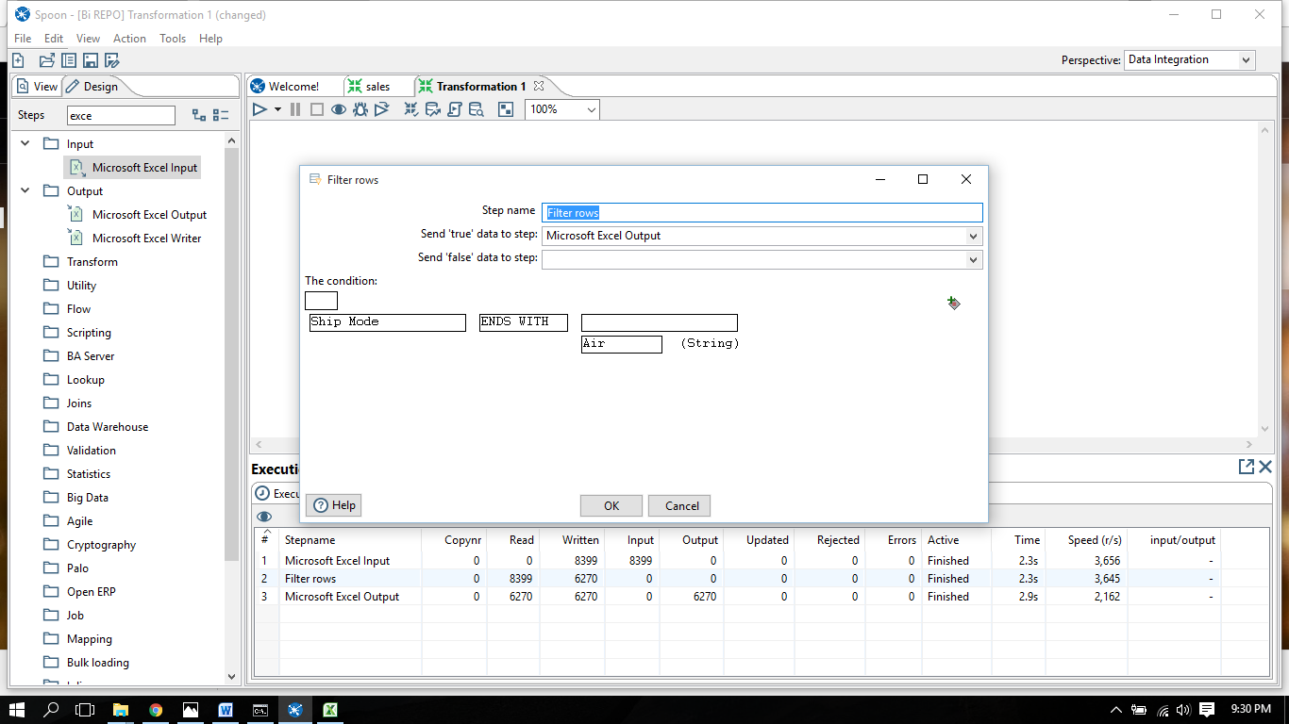

RESULT :

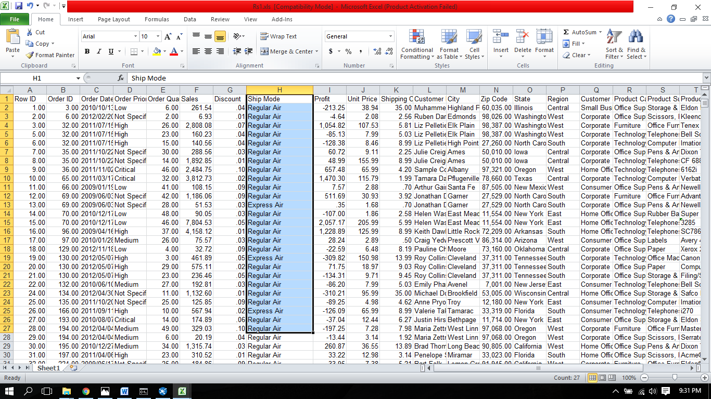

3. Where order id = 32

CONDITION:

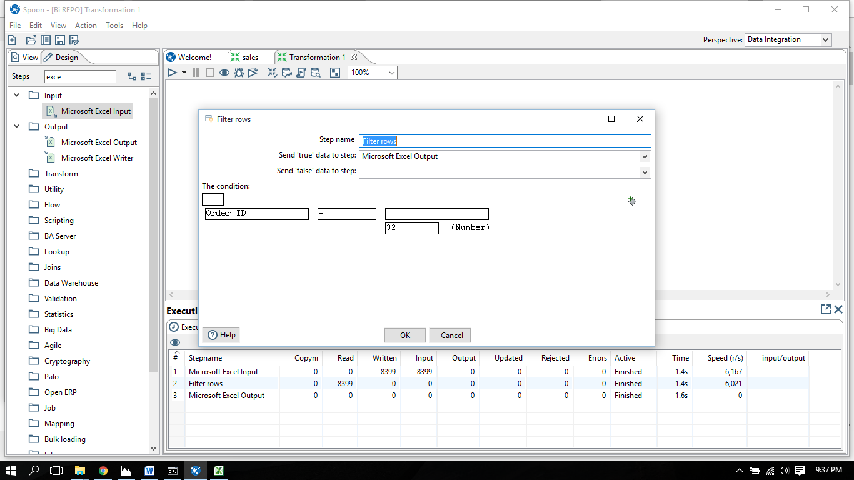

RESULT :

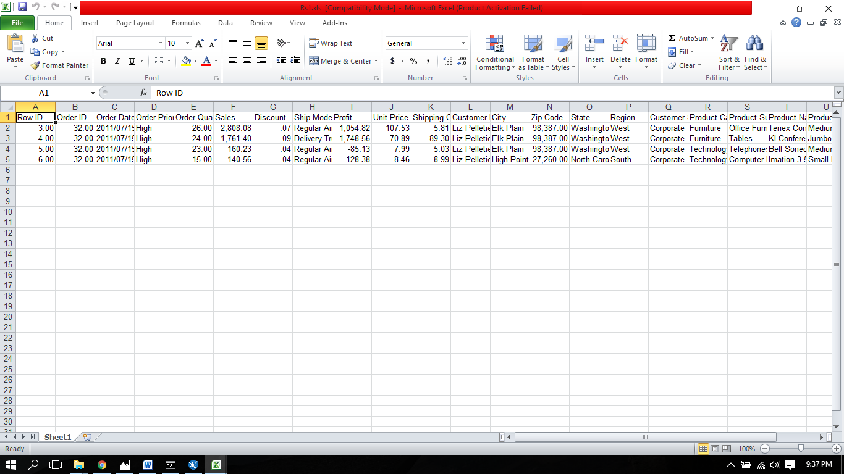

4. Where REGION IS NULL

CONDITION:

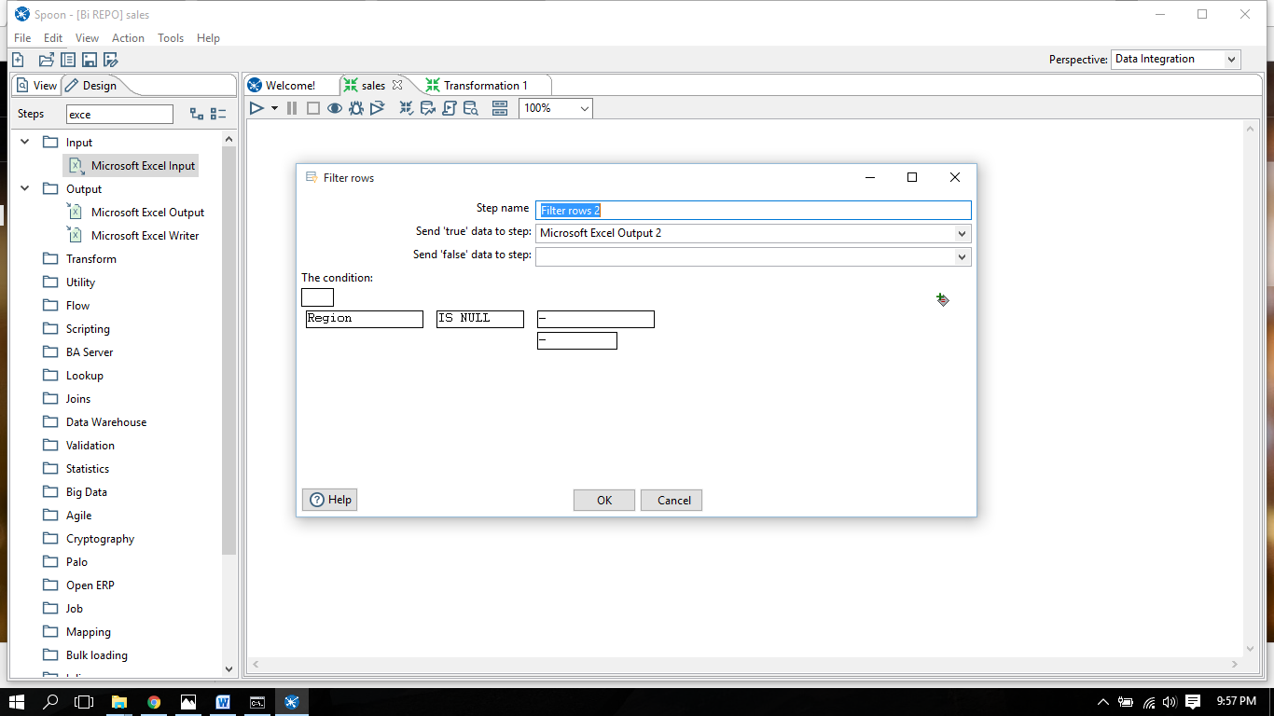

RESULT:

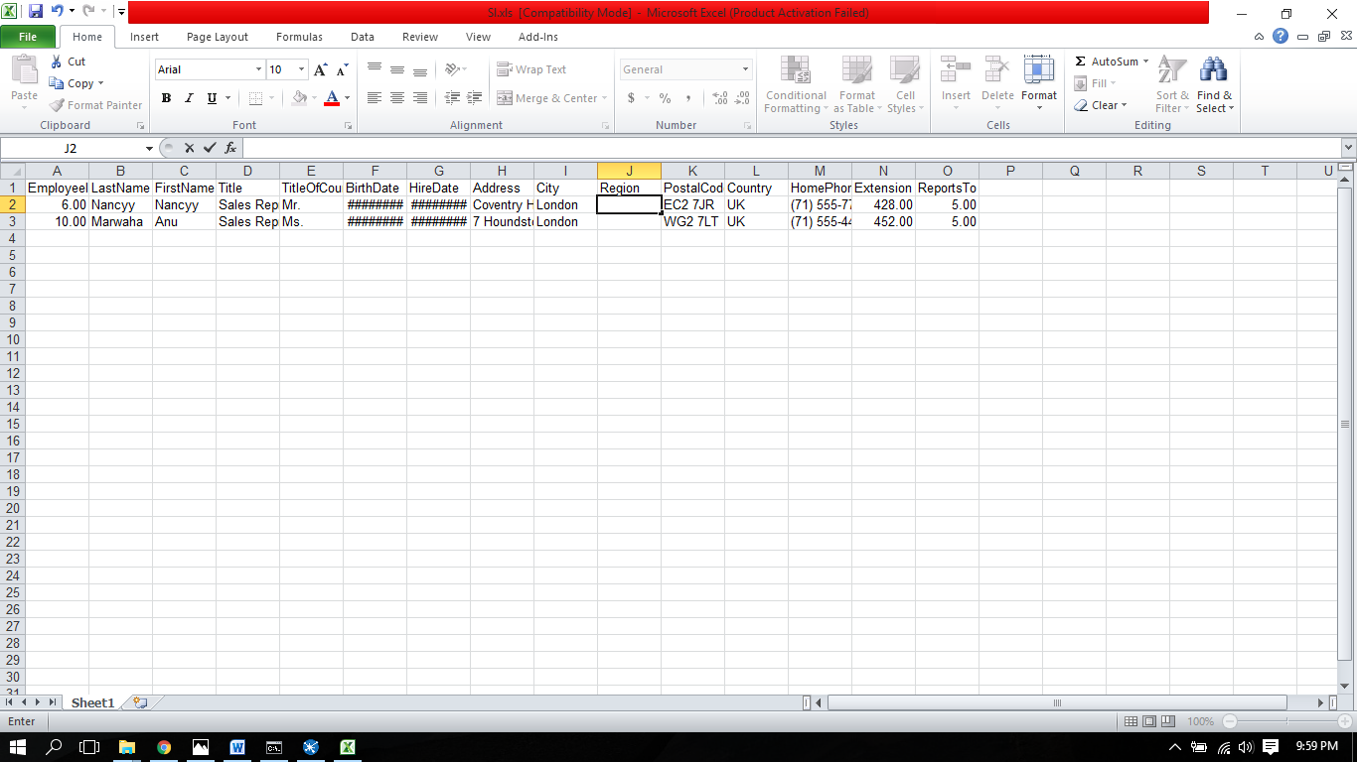

5. Where REGION IS NOT NULL

CONDITION:

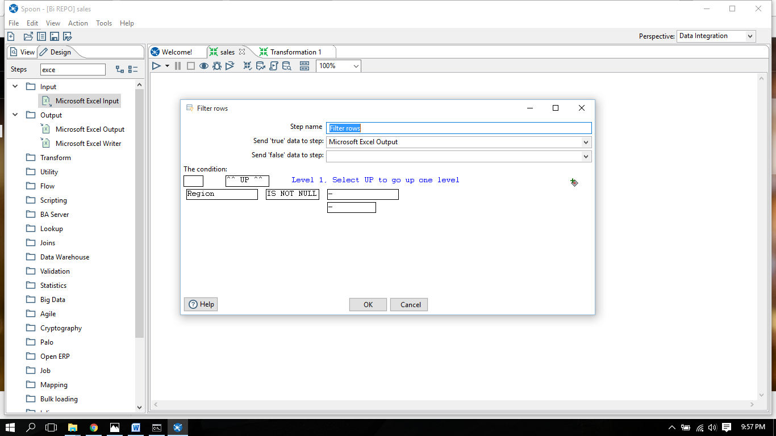

RESULT:

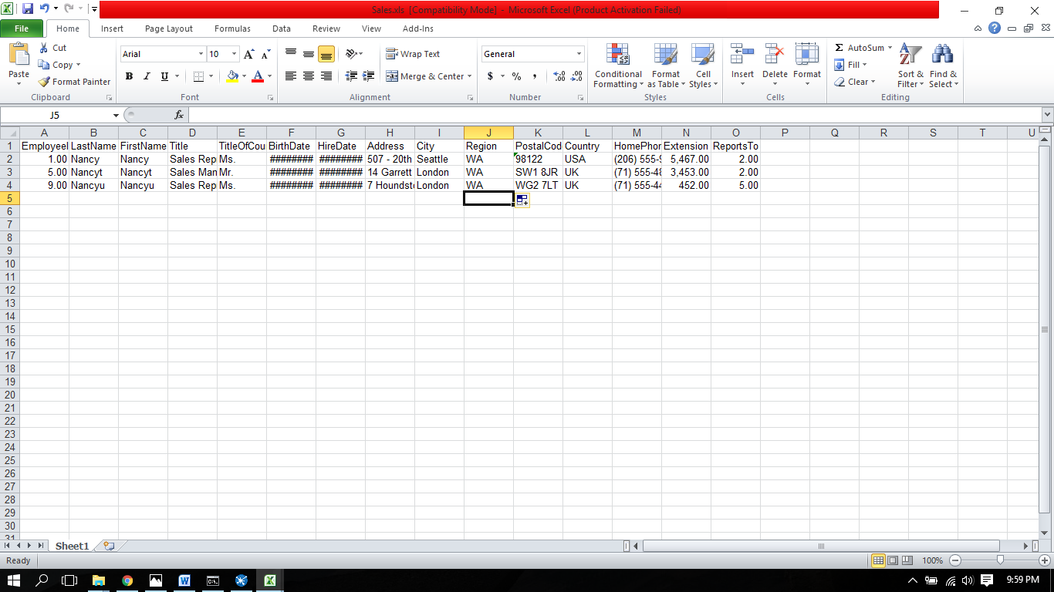

6. Where title of Curtsy is Mr

CONDITION:

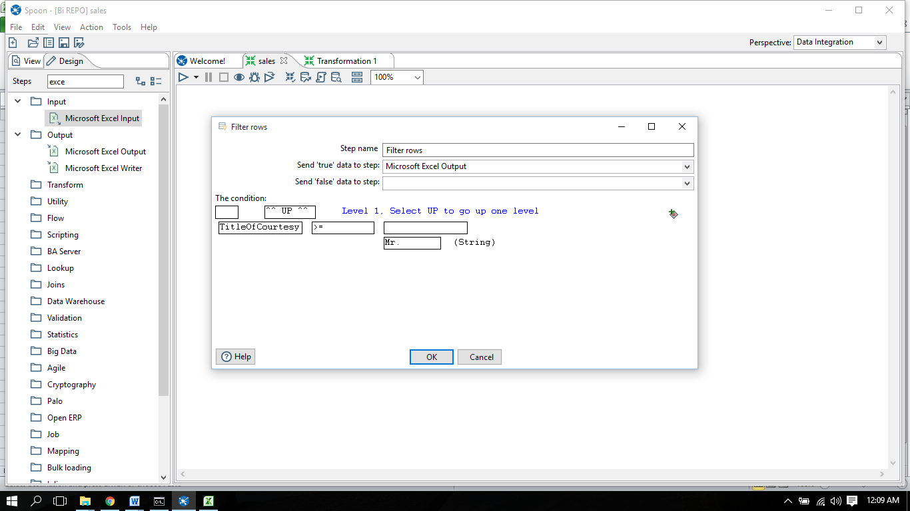

RESULT:

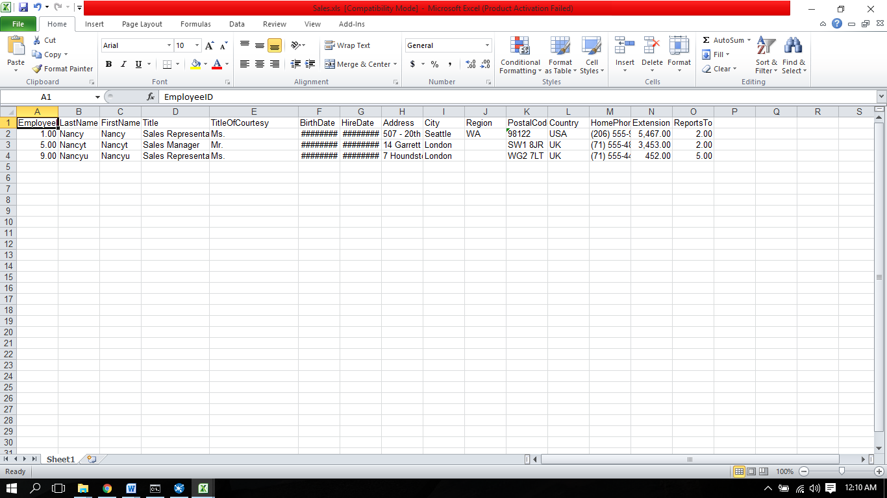

7. Where hire date >= 17.10.93

CONDITION:

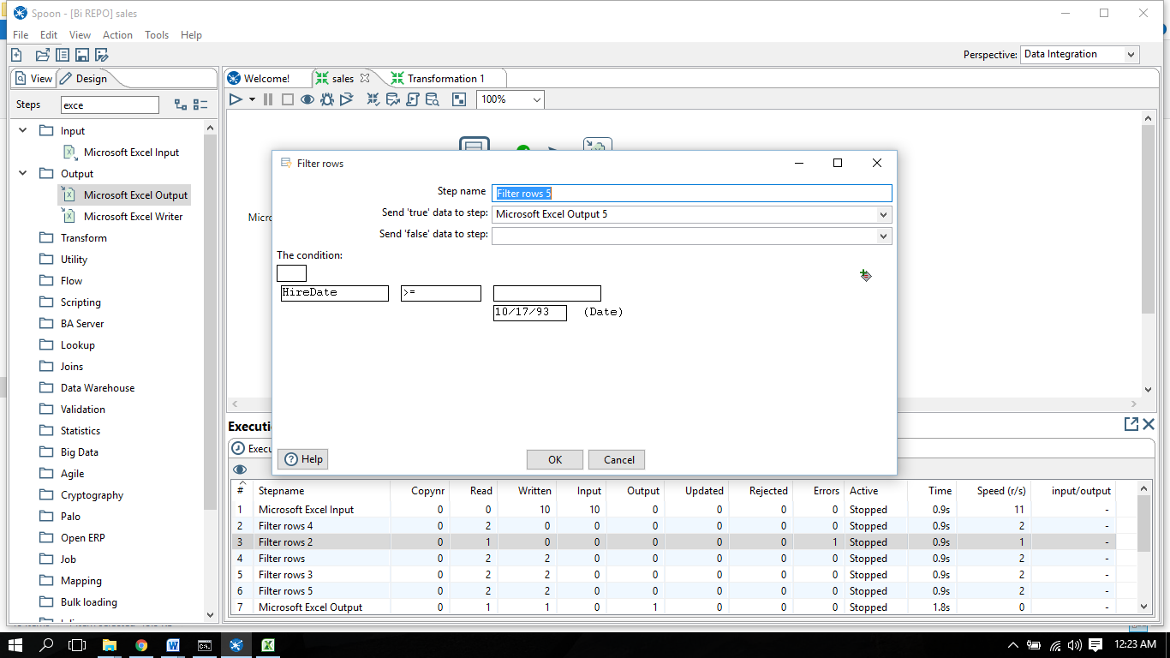

RESULT:

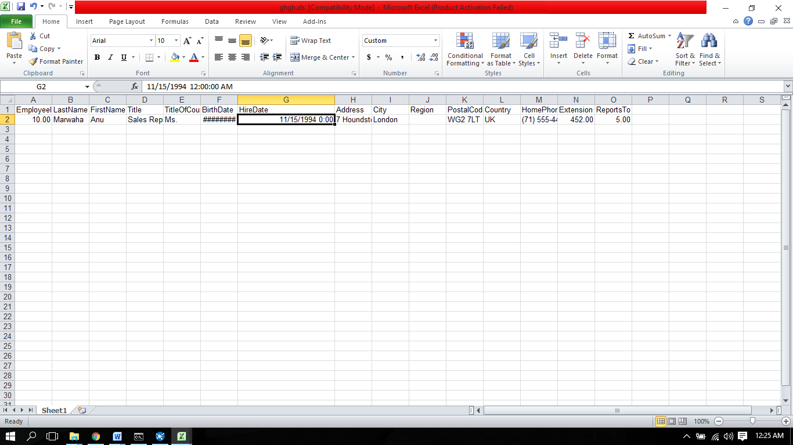

8. Where order quantity contains 6

CONDITION:

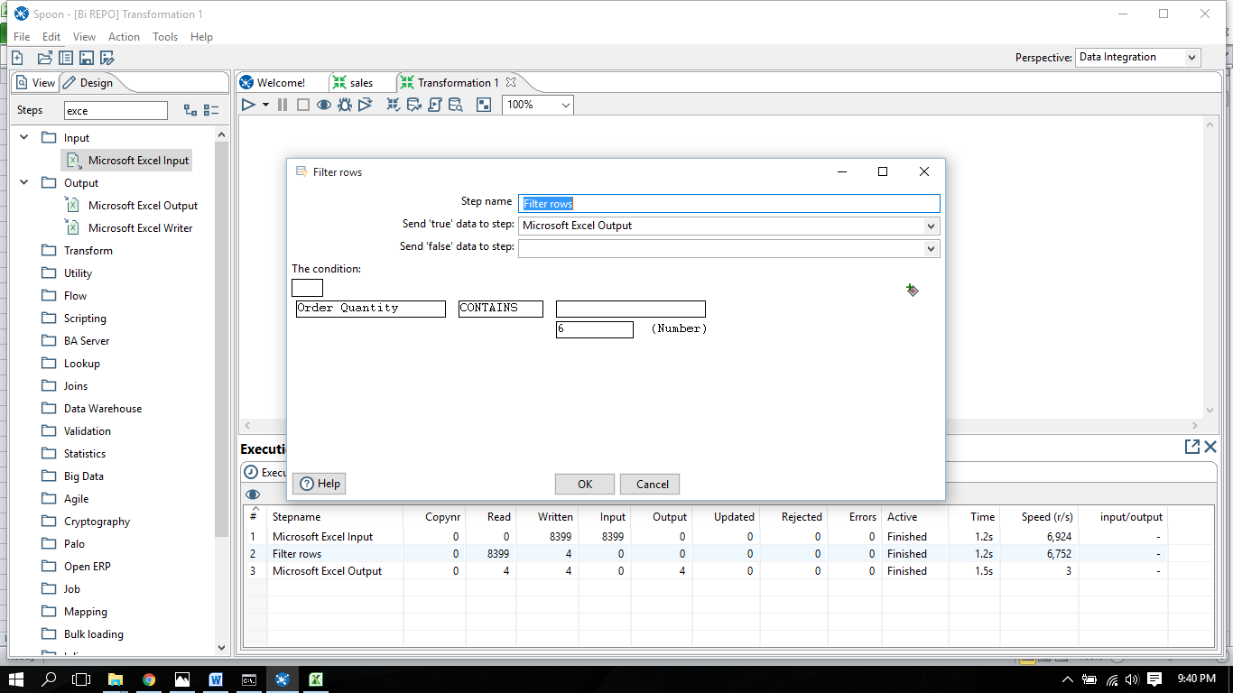

RESULT:

